REPORT FOR: | CABINET
Date of Meeting: | 18 July 2013
Subject: | Transformation of Day Opportunities in Harrow
Key Decision: | Yes
Responsible Officer: | Paul Najsarek, Corporate Director of Community, Health and Wellbeing
Portfolio Holder: | Councillor Krishna James, Portfolio Holder for Adult Social Care, Health and Wellbeing
Exempt: | No
Decision subject to Call-in: | Yes
Enclosures: | Appendix A – January 2013 Cabinet Paper on Transformation of Day Services  Appendix B – Consultation Summary Report  Appendix C - Table of building/capital considerations  Appendix D – Equalities Impact Assessment  Appendix E – Map Showing Day Service Locations in Harrow

Section 1 – Summary and Recommendations

This report follows a Cabinet decision in January 2013 to consult on a new model of day opportunities in Harrow. It sets out the conclusions of this consultation and further work that has taken place. It makes recommendations for transforming day opportunities in Harrow.

The report proposes a new model of services that focuses on supporting those with highest needs in the council’s high quality day services. This will ensure that we are able to support the most vulnerable, locally, allowing them to benefit from specialist care and support within the borough. Alongside this we will further develop personalisation and choice to provide a range of innovative support options in the community for people with personal budgets.

The review includes all day opportunities used by the borough, including a particular focus on seven day centres provided by Harrow Council, and a long-term block funded day service at Sancroft Hall. Extensive consultation has taken place with service users, families, advocates and staff working in the services. Consultation was focused on what a potential service model would look like including a number of key aspects which were outlined in the January’s Cabinet paper.

Supporting the most vulnerable people in the community is central to the work of Harrow council. The council will continue to ensure that people receive the care and support they need to be as independent as possible and to be treated with dignity and respect. Through this report we are seeking to ensure that we continue to safeguard the needs of vulnerable people by ensuring that services are as high quality, efficient, and as effective as possible. In addition services should represent value for money, sustainability, and be able to respond to both current and future needs.

The recommendations in this report aim to deliver a modernised service that offers improved outcomes, delivers the Medium Term Financial Strategy (MTFS) savings of £600k over 2013/14 and 2014/15, whilst delivering the vision of enhancing our residents’ quality of life and offering excellent service.

Recommendations:

Cabinet is requested to agree a two phase approach to transforming day opportunities in Harrow which will facilitate the transition to a new service model. This model will offer specialist services to those with greatest needs, whilst building on personalisation and choice and developing a greater range of day opportunities in the community.

Recommendation 1: Cabinet is requested to agree a new service model, which incorporates a focus on internal services for those with the highest needs, provided in specialist environments and in which people with lower needs will be supported by alternative providers in the community

Phase One: Reducing & Rationalising Buildings

During Phase One, we will make operational changes to services to tackle the current over provision of spaces and offer best value for money. This will deliver required MTFS savings during 2013/14 whilst moving towards the proposed service model.

During this phase we will reduce the number of council’s buildings used by in-house services from seven to four. Capacity at Sancroft Hall will also be utilised as we move to this approach. Current vacancy levels in all five facilities will ensure that we can continue to offer high quality day opportunities as we transition to the new model.

We will support service users to maintain friendship and peer groups, which consultation has demonstrated to be important to them. Services provided will be at the current level, and of a similar type. We will commence planning for comprehensive reviews of individual needs to take place in Phase Two.

Phase Two: Longer Term Changes to Delivery in NRCs

During Phase Two we will implement changes to deliver the new day opportunities model. This will include the development of specialised services to meet the needs of the most vulnerable in the community.

Phase two will involve changes over a period of time, including individual assessment and support planning to help people to identify the most appropriate service for their needs.

Recommendation 2: Cabinet is requested to approve the transformation of individual services during Phase Two of implementation, as described below:

A: Byron Neighbourhood Resource Centre - A specialised service will be provided for people with a learning disability including challenging behaviour and Autism

B: Kenmore Neighbourhood Resource Centre - A specialised service will be provided for people with Complex Physical and/or Sensory Disabilities

C: Vaughan Neighbourhood Resource Centre - A specialised service will be provided for people with a learning disability and complex needs.

D: Milmans Neighbourhood Resource Centre - A specialised service will be provided for older people including people with dementia

Recommendation 3: Cabinet is requested to approve that the council ceases to use the following buildings for day opportunities for vulnerable people:

Bentley Neighbourhood Resource Centre – the council will consider alternative use or potential disposal of this property. (Officers are not asking for permission to dispose of this property in this recommendation – this would require a separate decision by cabinet)

Gordon Avenue – Officers would negotiate with the owner of the property in relation to changing/ending use.

Bedford House – The building will continue to be used as a permanent residential care home for ten people with a learning disability as approved by Cabinet in March 2013. The council will consider the future use of this building. (Officers are not asking for permission to dispose of this property in this recommendation – this would require a separate decision by cabinet)

Recommendation 4: Cabinet is requested to amend the capital programme so that this resource can be made available for capital works which arise from this review, and the recent review of Residential Care services. This would rename the capital project for "Bentley Day Centre Remodelling and Refurbishment" to "Remodelling and Refurbishment of Adult Services Residential Care and Day Care Services".

Cabinet are asked to note the following:

- The further development of a marketplace of community-based services for people with personal budgets delivered through the council’s on-line market place – My Community ePurse.
- The further development of integrated services, offering a greater range of health related services and therapies within the four designated Neighbourhood centres and other community facilities as part of the new responsive model of day opportunities.

Reason for recommendations

The development of this new model of day opportunities for vulnerable people in Harrow will:
- Deliver a model in which services are strategically aligned and financially affordable for the future
- Ensure that the London Borough of Harrow is using its resources to support those most in need in safe and high quality services
- Deliver revenue savings of £300k in 2013/14 and £300k in 2014/15
- Ensure that we use the buildings available to us in the most effective and efficient ways
- Support greater integration of health and social care services in order to develop improved seamless, preventative services e.g. using centres for physiotherapy and health education
- Respond to the changing demographic profile of people who use day opportunities e.g. by providing services that are able to respond to young people with severe autism and challenging behaviour
- Support staff delivering services and avoid staff redundancies where possible

Implications of recommendations

The report outlines detailed information about the implications of the changes set out in recommendations. These are summarised in brief in this section.

Equality considerations / mitigations
Section 5.7 of this report considers equality impacts of the recommendations made, both positive and negative, and outlines potential mitigations. Amongst the key considerations are:
- A fear or perception that current day service provision may be partially or fully withdrawn. To mitigate all service users with an assessed need for support will continue to access a service to meet their needs
- A loss of friendships, routines and support from staff if service users have to move to an alternative service. To mitigate this potential impact Phase One of the recommended proposals would ensure service users are moved together in groups, appropriate support is provided in implementation, and staff would move to alternative services where vacancies exist
- Currently in-house day service activities do not match all the needs of young people coming through transition who have expressed a need for activities that will help with gaining employment. Harrow as pioneers of Personalisation have piloted and are now in the implementation phase of a new solution called My Community ePurse which will dramatically improve accessibility to personal budgets and lead to greater choice of services and activities for service users

Capital considerations
Section 5.2 of this report outlines capital considerations of implementing the recommendations. The following are key points:
- Approval to implement recommendations would create an opportunity for potential disposals of Bentley Day Centre and Gordon Avenue Day Centre. There is potential for further consideration of the long-term use of Bedford House
- Three of the buildings that we propose to use in the recommendations are PFI funded projects. These buildings are subject to long-term commercial arrangements and require negotiation and agreement prior to any change of use
- Any capital works to buildings that are retained in the new service model would require Portfolio Holder, Corporate Director and Capital Forum approval based on a clear business case
- A gym facility would need to be provided within Kenmore to replace the one that is currently in Bentley
- A number of voluntary sector groups use the buildings in this review. Where changes would impact upon these, Officers will work with groups to understand their requirements and to support them to identify alternative premises

Staff implications
Section 5.3 of the report considers impacts on staff working in the services affected. Key points are:
- There are currently 86 people working within the internal services that are the focus of this report. A number of these staff work part-time hours, such that in total there are 62.1 full time equivalent staff in the service
- The council currently uses a number of agency staff in the delivery of these services alongside permanent full and part-time staff
- Based on recommendations in the report there are currently 11 full time equivalent staff that would be at risk
- The council is committed to avoiding redundancies through redeployment where possible. An aspect of the implementation of recommendations would be formal consultation with staff and Unions

Section 2

2.1 Introduction
Harrow Council is committed to supporting the most vulnerable people in the community as one of our key priorities. This report is just one part of the modernisation of Adult Social Care services in the Borough. This includes refocusing in-house residential services for people with learning disabilities and modernising mental health day opportunities.

Through this report, and implementation of the proposed recommendations, we aim to deliver efficient and effective services that are sustainable, provide excellent support and increase choice for vulnerable adults. The council’s strategic review of day opportunities will support the achievement of £300k in 2013/14 and £300k in 2014/15 as set out in the council’s Medium Term Financial Strategy (MTFS).

In January 2013 Cabinet approved a report in relation to a review of day opportunities in Harrow. Following this report the council undertook detailed consultation with service users, carer’s, external day service providers, staff, Unions and the voluntary sector. Cabinet approved engagement with partners to develop a model of day opportunities focused on ensuring adults have the personalised support that will help them to achieve positive outcomes and fulfilled lives.

Cabinet approved a number of key aspects of a proposed model for consultation, in which:

- We identify whether there are opportunities to integrate with the health service to develop an offer which helps people to develop their own skills in managing their long term conditions or disabilities.
- The services directly provided by the council focus on supporting those with the highest needs for example those with complex learning disabilities and people with advanced dementia
- We rationalise the number of building based council run day opportunities in order to deliver efficiencies and reduce the current over-capacity of services
- We explore options to continue to support people with lower level needs, potentially through models such as open access services, or through working with the voluntary sector in new ways
- We encourage community engagement in the delivery of services to vulnerable adults. In particular increasing opportunities for volunteering, peer support and supported employment
- We develop the market of day opportunities to ensure people have a choice of services

We have now completed a 12-week statutory consultation on day care. In total we talked face to face with 477 people and we received 164 completed questionnaires. A breakdown of consultees is presented below:

Consultation participants | No.
Consultation meetings: Seven Harrow Council provided day service users | 183
Consultation meetings: Sancroft, Welldon and Shaw Trust | 60
Consultation meetings: Carers | 63
Consultation meetings: Tanglewood, sheltered accommodation, special schools | 93
Consultation meetings: Staff, union and day service providers | 78
Questionnaire respondents | 164
Additional written submissions and telephone feedback | 8
Total Number of consultation participants | 649

This report considers the responses to the consultation and potential impacts on vulnerable people. A summary of responses is found in Section 3 of this report.

The options set out in this report have been developed following consultation and engagement with service users, their families, advocates, staff working in the internal day opportunities under review and external day service providers. The feedback received during consultation has contributed to the final recommendations set out in the report.

Officers have sought to set out all relevant information in this report in order to enable Cabinet to make a fully informed decision, and to be compliant in all areas of procedure and legislation/duties. In doing so we have learnt from previous reports, including a recent report on Residential Care services which was subject to a Call-In hearing that unanimously identified that the process had been thorough and robust. As a result of this additional scrutiny we have improved this report with the addition of “Implications of Recommendations” to Section 1, we have sought to ensure that recommendations, including capital considerations, are very clearly articulated and Legal Implications are clear both in terms of legal duties and processes for making a decision.

It is relevant to note that the council is currently conducting a Special Needs Transport service review. This is looking at transport, for a range of vulnerable groups including users of day services. The main aims of the review are to introduce more independent travel and increase the use of personal budgets. The group working on this project includes representation from adult services and has been kept fully informed of progress with this review.

2.2 Services in the Review
The January Cabinet Paper considered the services in the review in detail. This report is attached at Appendix A.

In summary:
- The council currently spends £6.180m per year on supporting 626 people to attend a range of day opportunities provided in both internal and externally provided settings
- Services support people who are older and frail, have a learning disability or who have a physical or sensory disability
- Services are provided through a mix of internal and external services. 47% of people use internal services, 34% use block contracted services and 19% use spot purchased services or use a personal budget

Internal Services:
- Harrow Council directly provides seven day services including the three PFI neighbourhood resource centres - the current net cost of these services is £4.134m inclusive of transport, internal overheads and borrowing costs
- The council provided services are Bentley, Milmans, Byron, Vaughan, Kenmore, Gordon Avenue and Bedford House

External Services:
- The council currently uses a wide range of externally provided services that are used by around 400 people, costing £2.046m (including Sancroft Hall)
- A long-term block contract provides the equivalent of 250 days of day care at Sancroft Hall for £491,463. Residential care and respite care are also provided at the service
- A range of other day services are purchased through personal budgets

2.3 Why a change is needed
The paper presented in January contained a detailed analysis of the case for changing services. This included evidence of a number of different drivers for change. Below is a summarised version of key messages:

Current use of services:
During a Continuous Improvement Exercise in 2012 we identified that the number of people using some of the internal day opportunities is significantly below capacity. In particular, Milmans and Bentley are supporting around 40% of the people that they have capacity for. As services continue to need similar levels of staffing to run, this makes them less efficient.

In April 2012 a new Fairer Contributions Policy introduced charging for day care. This has led to a reduction in service user attendance. A number of service users stopped attending rather than pay towards the cost of the service. All who stopped were subsequently contacted to ensure that there were no safeguarding issues as a result of non attendance.

Analysis of those attending the internal day services highlighted that young people with disabilities are not accessing them. This appears to be due to a range of factors – for example that they are choosing to use their personal budgets for other activities; their needs cannot be successfully met and they are attending specialist services; or families are keen for young people to maximise their learning potential at a service with an educational focus.

Information about the current use of services points clearly to a need to reduce the overall capacity of services we provide, and to ensure they are able to meet the needs of people with complex needs and young people.

Finance & Efficiency:
The January Cabinet Paper considered the financial and efficiency aspects of current services in the review in detail. This report is attached at Appendix A.

Financial benchmarking data indicates the council spends relatively more on day opportunities for those with complex needs (learning and physically disabled service users) than when compared with the London average.

Average Gross Exp per Day of Care | Harrow | London Average
Older People | £74 | £144
Learning Disabled | £467 | £354
Physically Disabled | £278 | £229

Further analysis demonstrates that this is caused by a high number of people using services, and the higher than average costs of supporting people aged below 65. Harrow is in the top quartile in terms of numbers of people accessing services.

The cost per service user with learning and physical disabilities of using day services is in the top half. The relatively higher cost per person reflects both the complexity of support needed by many people with disabilities and the fact that a high proportion of service users attend the internal services for five days each week.

These averages can be mis-leading however, services meet a variety of needs and so they do not have standard costs. For example the cost of providing external support to people with learning disabilities varies from £17 to £240 per day.

As Harrow moves towards every eligible user having a personal budget the cost of services needs to be seen in terms of affordability for service users rather than for the council as a whole. In the future individuals will be given a financial allocation from which they need to purchase services to meet their assessed needs.

In this context it becomes clear that the council needs to ensure the provision of affordable and high quality services, whether directly provided or in the market place. This has very important potential implications for the provision of internal services as they will no longer have a guarantee that people will choose to use them.

The conclusion from analysis is that in the future only services that are cost effective and able to meet people’s needs within their personal budget entitlement will be sustainable. Internal services will inevitably have high fixed costs due to their specialist facilities and therefore will be more sustainable if they focus support to people with higher needs requiring complex support packages.

The PFI-NRCs (Vaughan, Byron & Kenmore) are best placed to support people with the most complex needs efficiently as they were designed for this purpose.

Demography:
Demographic projections suggest an increasing number of people are likely to need services in the future, with increasingly complex needs.

Available data indicates increasing numbers of older people with dementia and people with complex disabilities who will require specialist support to maintain their independence and wellbeing.

Advances in medical treatment mean more young people with very complex needs are surviving into adulthood; services need to be available to support them.

Demographic information indicates that we will need more capacity in services for older people, particularly those with dementia, and for people with complex needs in the future.

Statutory and Policy Framework:
The council has a statutory duty to provide facilities for occupational, social, cultural and recreational activities to those who are assessed as eligible.

The personalisation agenda continues to provide the driving strategic force for adult social care in England. A key role of adult services is to ensure that people are supported to be as independent as possible.

Guidance points to the need for high quality and personalised services. Day opportunities in the future will need to be very different from services provided in the past. There is an expectation they will be user led, through personal budgets rather than block contracts and that they will be flexible and able to meet individual’s aspirations.

As a result of Personalisation the council needs to ensure the provision of affordable and high quality services, whether directly provided or in the market place. In addition, the Government's 2012 draft Care and Support Bill proposes placing a duty on councils to ensure service users can access a diverse market of providers.

The introduction of Personal Budgets has led to several delivery challenges including accessibility and ensuring real choice and control. Harrow as pioneers of Personalisation have piloted and are now in the implementation phase of a new solution called My Community ePurse. This will dramatically improve accessibility of personal budgets and lead to greater choice of services and activities for service users.

Through My Community ePurse service users will be able to receive funding and purchase services all in one place, without the need to setup a separate bank account or keep paper records. Harrow will be able to provide each service user or their representative with an electronic purse, which will allow them to choose and purchase services through Harrow’s Online Market Place. Harrow is the first Local Authority in the country to be able to offer this solution.

Utilising mobile technology the Personalisation Teams will be able to assist anyone without access to the Internet. This will support service users and their families through the entire process to develop and maintain their own online support plan to meet their identified outcomes.

Harrow Council is working closely with the voluntary sector and other organisations to develop the local marketplace to be able to offer more services and activities through My Community ePurse. We have been greatly encouraged by their interest in developing this into a real Community Hub.

Since the January Cabinet report was written the Government’s review into failings at Winterbourne View has been published. The review into shocking failures of care to people with challenging behaviour found that they have too often received poor quality and inappropriate care. The report found that many people are admitted to hospital unnecessarily and once in hospital they stay too long.

Some of the key findings are relevant to this review. These include:
- People have a right to be offered the support and care they need in a community-based setting, as near as possible to family and other connections
- Commissioners must design, commission and provide services which give people the support they need, in line with well established best practice

These findings further suggest a need for the council to ensure the provision of safe, high quality, local services to ensure those with the highest and most complex needs are able to receive the support they need in Harrow.

Integrating Health and Social Care:
The number of people in England who have health problems requiring both health and social care is increasing. For example, in the next 20 years, the percentage of people over 85 will double. This means there are likely to be more people with ‘complex health needs’ (more than one health problem) who require a combination of health and social care services. These people are likely to require a range of services to maintain their independence including day opportunities.

The Health and Social Care Act 2012 sets out specific obligations for the health system and its relationship with care and support services. This gives a duty to NHS England, Clinical Commissioning Groups, Monitor and Health and Wellbeing Boards to make it easier for health and social care services to work together to deliver integrated support systems to meet local needs.

Proposed Legislation:
The Government has proposed a Care Bill which is currently being considered by the House of Lords. This will reform the social care system and will have a range of implications for councils, notably a number of additional duties and requirements. It is expected that impacts will start from 2015 onwards.

Of particular relevance to this paper is consideration of the impacts of Dilnot proposals. These will lead to a cap on individual contributions to care, which will ultimately mean that the council funds eligible care for all in the community, rather than just those who cannot afford it. This will lead to a substantial increase in the number of people supported by the council as at present “self-funders” often do not become known to us. There is potential that this will identify un-met needs in the community and could lead to an increase in the numbers of people needing to access day opportunities in the future.

In addition the care cap there will be extra duties on local authorities to provide information and advice, ensure provision of preventive services, and to provide services to carers. These all have potential to create additional pressures on adult social care.

Section 3: Consultation & Analysis
This section of the report provides information on capacity and service use within the current seven day services and the external contract at Sancroft for day care. Sancroft, although not council-owned or provided, is included here alongside internal services, as unlike personal budget funded services, the council pays for services directly and has a role in defining the type of service that is provided. The second part of this section provides analysis of the formal consultation on day opportunities.

3.1 Data Analysis

3.1.1 Internal day services
In considering the future model of day opportunities it is necessary to assess capacity and current regular up-take of these services. The council has a duty to meet assessed needs, day opportunities are one of the options that people are able to choose to meet their needs. The challenge to the council is to ensure that internal services are able to respond to current and future demand for services including the ability to respond to local demographic changes.

Table 1 below shows the capacity, planned and actual service use in each of the council provided day centres during the sample month of February 2013. This reflects actual attendance for planned day care and raises issues of take up of places allocated.
Table 1 - Actual, planned and capacity statistics February 2013

Day Service | Capacity per day | Capacity  (i.e. no. of day places available each week) | Current planned day places*  (i.e.: no of day places allocated each week) | Utilisation  (planned) | Average actual places taken up each week | Utilisation  (Actual)
Byron NRC | 40 | 200 | 150 | 75% | 122 | 61%
Vaughan NRC | 30 | 150 | 151 | 100% | 131 | 87%
Kenmore NRC | 30 | 150 | 137 | 91% | 99 | 66%
Gordon Avenue Day Service | 9 | 45 | 30 | 67% | 29 | 64%
Bentley NRC | 64 | 320 | 105 | 33% | 86 | 27%
Bedford House Day Service | 9 | 45 | 41 | 91% | 41 | 91%
Milmans Day Centre | 50 | 250 | 124 | 49% | 79 | 31%
Sancroft Day Centre | 50 | 250 | 153 | 61% | 121 | 48%

Some of the day centres show a significant percentage of planned use which does not take place, in Milmans for example only 63% actually attended. As many of the service users are frail, sporadic attendance may be due to periods of ill health.

The percentage of service take up compared to capacity identifies significant issues:
- Only Bedford House and Vaughan are operating at more than 85% of capacity actually being taken up, which is a figure we would consider an acceptable level;
- In Bentley day centre planned attendance is only 33% and actual attendance only 27% of capacity;
- The five remaining centres are showing actual attendance between 31% and 66% of capacity.

The lack of take up may be caused by a number of factors. The January Cabinet report highlighted the impact on uptake of day care following the introduction of the Fairer Charging Policy in 2012. This policy has meant people who can afford to are expected to make a contribution towards the cost of their services. This has led to some people to decide they no longer wish to attend. In addition, it may in part be due to people spending their personal budget in a different way, or that activities are not attractive to potential service users. Work continues to increase the range of services on offer to attract service users (e.g. a Reablement programme has been introduced at Bentley NRC which has proved very popular). Services have also made attempts to market services to people in other boroughs.

The difference between capacity and planned service take up provides a clear indication of the level of change needed.

3.1.2 External Day Centre Contract
The council currently spends £491,463 a year on a contract for day care for older people at Sancroft Hall. This is part of a 25 year PFI project, which includes residential provision for older people. The PFI contract still has 12 years to run (ends 2024).

Table 2 below highlights an issue in that the number of people attending this service range between 38.2% and 54.7% as a percentage of capacity. Officers are working with the provider to maximise the opportunities at the centre.

Identifying how Sancroft will become part of the future service model, and how issues of take up will be tackled, represents a key challenge for the review.

Table 2 - Actual attendance and capacity during February 2013

February 2013 | Actual attendance - February 2013 | Capacity  (25 block contract places) | Attendance as a % of capacity
Anjali – Asian older people | 260 | 525  (21 days x 25 places) | 49.5%
Byron – dementia service | 164 | 300  (12 days x 25 places) | 54.7%
Maya – Asian older people | 86 | 225  (9 days x 25 places) | 38.2%
As with internal services Sancroft staff have indicated that the numbers of people attending have fallen since the Fairer Charging Policy has been introduced.

3.1.3 Conclusion:
A clear conclusion from these figures is there is a need to reduce the number of units available. The current level of service take up causes services to be inefficient and increases the cost of supporting each service user.

Despite the low level of take up, services continue to be staffed at similar levels to their full capacity. This is because safety must be maintained and building need to adequately staffed.

3.2 Consultation Process

3.2.1 About the Consultation
The Council has carried out statutory consultation over a twelve-week period from February 2013 to May 2013. This review focuses on the future shape of day opportunities in Harrow and specifically the seven services directly provided by the London Borough of Harrow. The services under review are:

- Byron Neighbourhood Resource Centre (NRC) for people with learning disabilities
- Kenmore NRC for people with learning disabilities
- Vaughan NRC for people with learning disabilities
- Gordon Avenue Day Centre for people with learning disabilities
- Bedford House Day Centre for people with learning disabilities.
- Milmans NRC for older people
- Bentley Day Centre for disabled people

In addition the service provided under contract by The Freemantle Trust at Sancroft Hall is operating under capacity and is also being considered. This service is provided to older people and has a particular focus on supporting Asian elders.

There is a wider market place of day opportunities in Harrow. These provide services to people who are self-funders and people who have a personal budget and choose to purchase them. These services are not commissioned by the council and Cabinet do not have authority to change the way they deliver. However, we have engaged with these services, and those that use them, and identified the role we see them having in the future within recommendations. See Section 3.2.7 in relation to external provider consultation.

3.2.2 Who was consulted?
We have learnt lessons from previous consultation exercises and ensured the following aspects of a robust consultation:

- Service users – to ensure users were effectively engaged we posted a personal copy of the easy read questionnaire to every service user from each of the NRCs and held more than 20 events;
- Carers – we worked closely with our Lead Officer for Carers and with Harrow Carers to encourage them to give us their views on the proposed changes to services;
- Voluntary Sector Organisations – we invited local organisations to a separate consultation event, and wrote to them inviting them to submit a response to consultation;
- Councillors – we wrote to all Ward Councillors with a service in their Ward and invited them to the consultation events;
- Advocates – we invited advocacy groups to all events, invited advocacy organisations to respond formally to consultation, and identified people who have individual advocates through working with day centre staff.

The council went to great lengths to ensure the consultation was thorough and gave people the opportunity to make their views known. The consultation was delivered in accordance with the Corporate Consultation Standards, which are focused on ensuring it is accessible and involves the communities affected by the proposals.

Consultation sessions were well attended and engaged service users in discussions about options. The support of family members, advocates and in some cases key workers assisted with this process.

In total we talked face to face with 477 people. In addition we received 164 completed questionnaires. A breakdown of consultees is presented below:

Consultation participants | No. | %
Consultation meetings - day service user
Adults with learning disabilities (Bedford House Day Service, Byron NRC, Gordon Avenue Day Service, Kenmore NRC, Vaughan NRC) | 95 | 14.5
Adults with physical disabilities (Bentley Day Service) | 54 | 8
Older people (Milmans NRC) | 34 | 5
Sancroft (Contracted Day Service for older people) | 39 | 6
Welldon Activity Group | 18 | 3
Shaw Trust (Independently provided day service for adults with learning disabilities) | 3 | 0.5
Sub total | 243 | 37
Consultation meetings - other
Carers (of users of Harrow Council provided day services) | 63 | 9.8
Tanglewood (A weekly club for people with learning disabilities, some members may use a day service) | 50 | 8
Young people in transition (Shaftesbury High School and Kingsley High School) | 26 | 4
Sheltered accommodation residents (older people) | 17 | 2.5
Members of staff (attended the seven Harrow Council Day Service staff consultation meetings) | 60 | 9
Unions (One union member attending three different Harrow Council Day Service staff consultation meetings) | 1 | 0.2
Day Service providers (17 representatives from 14 provider orgs) | 17 | 2.5
Sub total | 234 | 36
Questionnaire respondents | 164 | 25
Additional written submissions and telephone feedback | 8 | 2

There were three written submissions from voluntary sector organisations and one from the NHS Harrow Clinical Commissioning Group. We received two letters from carers, one carer phone call and an email from the Bentley Day Service Users Committee.

In summary:

- Of the total 164 questionnaires completed and returned: 107 (65%) were completed by service users; 21 (13%) by carers; 17 (10%) by family members (who were in most cases also carers); and 10 (6%) by pupils from special schools. Other respondents included volunteers and advocates;
- Of the 32 consultation meetings, 22 were for users and carers. Three of these meetings were focussed specifically on Gujarati, Punjabi and Hindi speaking users and carers, facilitated by Harrow Council staff, whilst Gujarati speaking staff were available at the other events. We also translated the questionnaire, on request, to Gujarati. One of these 22 meetings took place at Harrow Civic Centre in the evening to enable people who could not attend a meeting during the day to engage in the consultation process. Additionally, there were a total of eight meetings with day centre staff whose views inform the consultation. There were also two meetings with young people in transition attending sixth form of special schools and a meeting with current and potential day opportunity providers;
- Events were publicised at centres, the council’s website and via local voluntary sector organisations;
- Voluntary sector organisations were involved in the design of the easy read questionnaire and the face-to-face meetings;
- We posted easy read questionnaires to every person who uses the Harrow provided day services. In addition, to making these available at every consultation event and via voluntary sector organisations;
- In addition to the easy read questionnaire, opportunities to respond were offered via face-to-face consultation meetings; a dedicated email address; and opportunities to speak to staff within the centres.

Unions and Ward councillors were invited to attend meetings. A Union member was present at three of the eight staff meetings. Voluntary sector organisations (Harrow MENCAP, Harrow Age UK, Harrow Association of Disabled People, and Harrow Carers) were invited to be members of a Consultation Project Group, together with Council officers.

In addition, key stakeholders, including advocacy groups, voluntary sector organisations and providers, were encouraged to respond formally in writing, via letter or email using a dedicated consultation email address, or by phoning officers coordinating the consultation.

Participating voluntary organisations encouraged users and carers to take part in consultation, through displaying the information at their venues, and including this information in their regular newsletters. Age UK and Harrow Mencap were sent copies of the questionnaires, which they helped service users to complete.

We have also received consultation responses from Harrow Clinical Commissioning Group, Harrow Association of Disabled People (HAD), Age (UK) Harrow and Harrow Mencap. These can be found in the consultation document in Appendix B of this report.

A full report of the consultation results is attached at Appendix B. This report contains a detailed summary of all consultation activity and responses. For the purposes of this report we have focussed on the following aspects of the consultation:

- The proposed future model for day opportunities in Harrow;
- The reduction in the number of buildings in use; and
- The aspects of day opportunities that are important to people.

A number of service users, carers and providers commented that they enjoyed their consultation event and found it informative and supportive. People also stated they had an opportunity to have their say and understood more about the options and reasons for the review of day services in Harrow.

3.3 Feedback Relating to Key Aspects of Consultation

This section of the report focuses on key areas of discussion in the consultation. There is a particular focus on areas relating to the future model of day opportunities in the borough.

More detailed analysis of the feedback to the consultation is included in the Consultation report in Appendix B.

3.3.1 Proposed future model for day opportunities in Harrow
Questions 3, 4, 5, 13, 15 and 16 of the consultation questionnaire:

The consultation focussed on two service options: one in which the council would focus more on supporting those with more complex needs, for example people with advanced dementia or people with severe autism and behaviour described as challenging. This proposed model also suggested people with lower level needs could be supported to access a wide range of services/day opportunities with their personal budgets.

Day opportunities may not necessarily be in a building and may include places that the general public use, such as libraries and leisure services. The central focus was on providing more choice and control to service users.

The second model was for the NRCs to be focussed in a different way in which lots of different people could access them as community hubs.

What people told us during the consultation
Service users and carers generally described the centres as a lifeline, enabling users to continue living in their own homes, and enabling carers to continue providing the necessary support.

When asked about whether a model focussed on moving people to personal budgets and the development of a wider range of day facilities the majority (100 people/61%) of people said the model might meet their needs but they would need some support.

Respondents were asked what support would be needed if the proposed model was chosen. People identified the following areas of support:

- To understand the implications of the model for each service user, one respondent stated, ‘to understand how the change will effect me’;
- Support with financial and administrative management of a personal budget;
- Information and advice about the availability and quality of new/alternative day services; and
- The availability of advocacy support to make informed decisions.

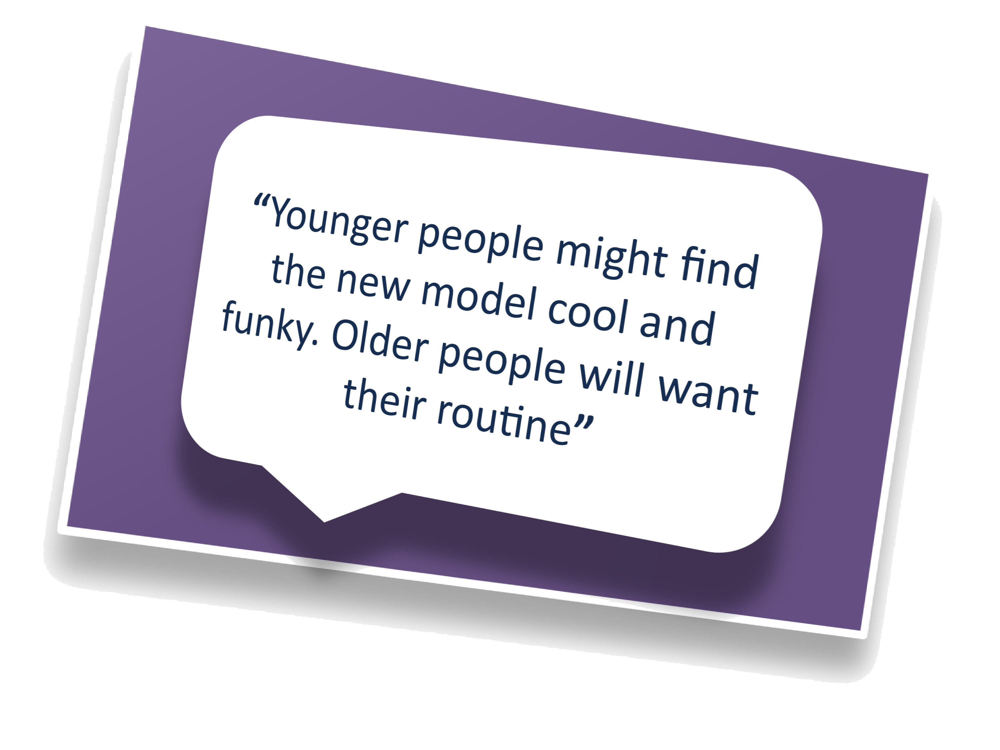
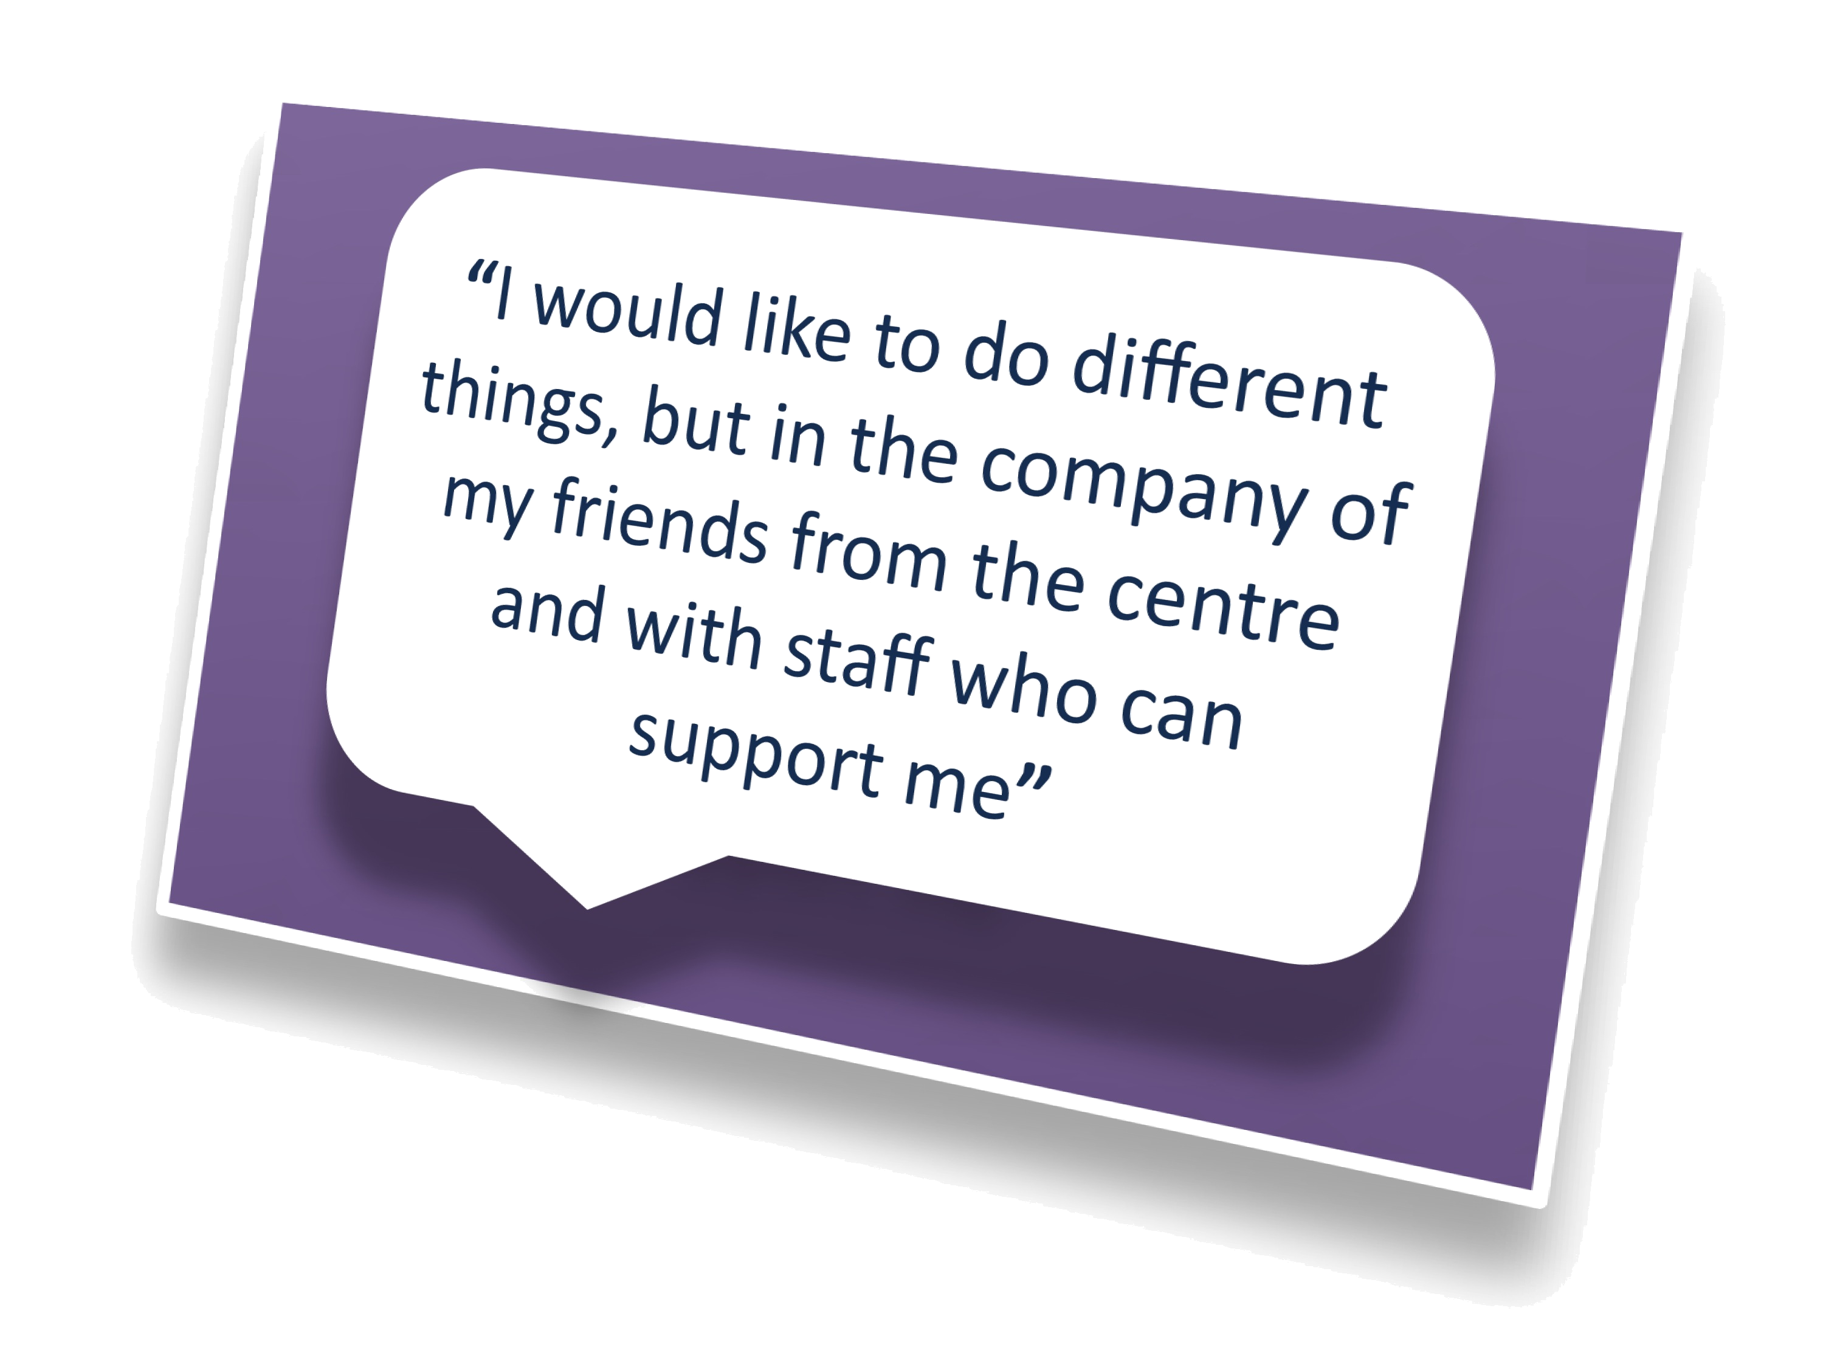
Many other respondents did not answer the question directly but stated they wanted to continue to receive a good day service, preferably without a change to current provision.

People were asked about whether in future NRCs should focus on providing day opportunities to people with a higher level of need (e.g. people with advanced dementia or people with a severe learning disability whose behaviour is described as challenging) and people with a lower level of need could purchase their support in the community via their personal budget.

In total 64 people (39%) responded to this question. There were almost equal numbers of people agreeing to or disagreeing with the proposed model. This response was anticipated and understandable. Many people would identify themselves as someone who either has a higher level of need so may experience a lesser change, or as someone who has a lower level of need and may experience more change if the NRCs were refocused. People identified a range of concerns about accessing the community via a personal budget. These included:

- People not wanting any change to their current service;
- A feeling that people with a lower level of need were considered to be less important;
- People are concerned about losing touch with friends or possible loneliness of accessing community facilities without a familiar group.

In the consultation events there was active discussion on the focus of this potential future model. At these events service users, carers and staff indicated support for a change in focus for the NRCs to meeting the needs of those with a higher level or complex needs. People highlighted the need for further development of activities in the community and more information on the impact for individual service users.

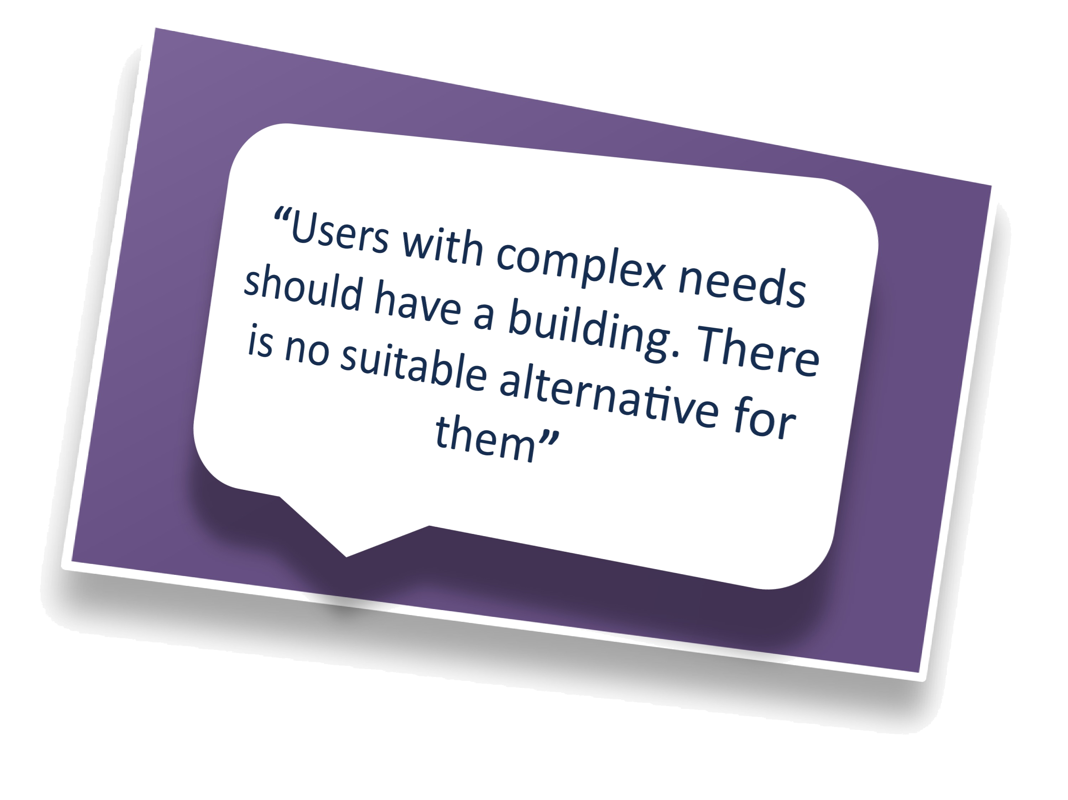
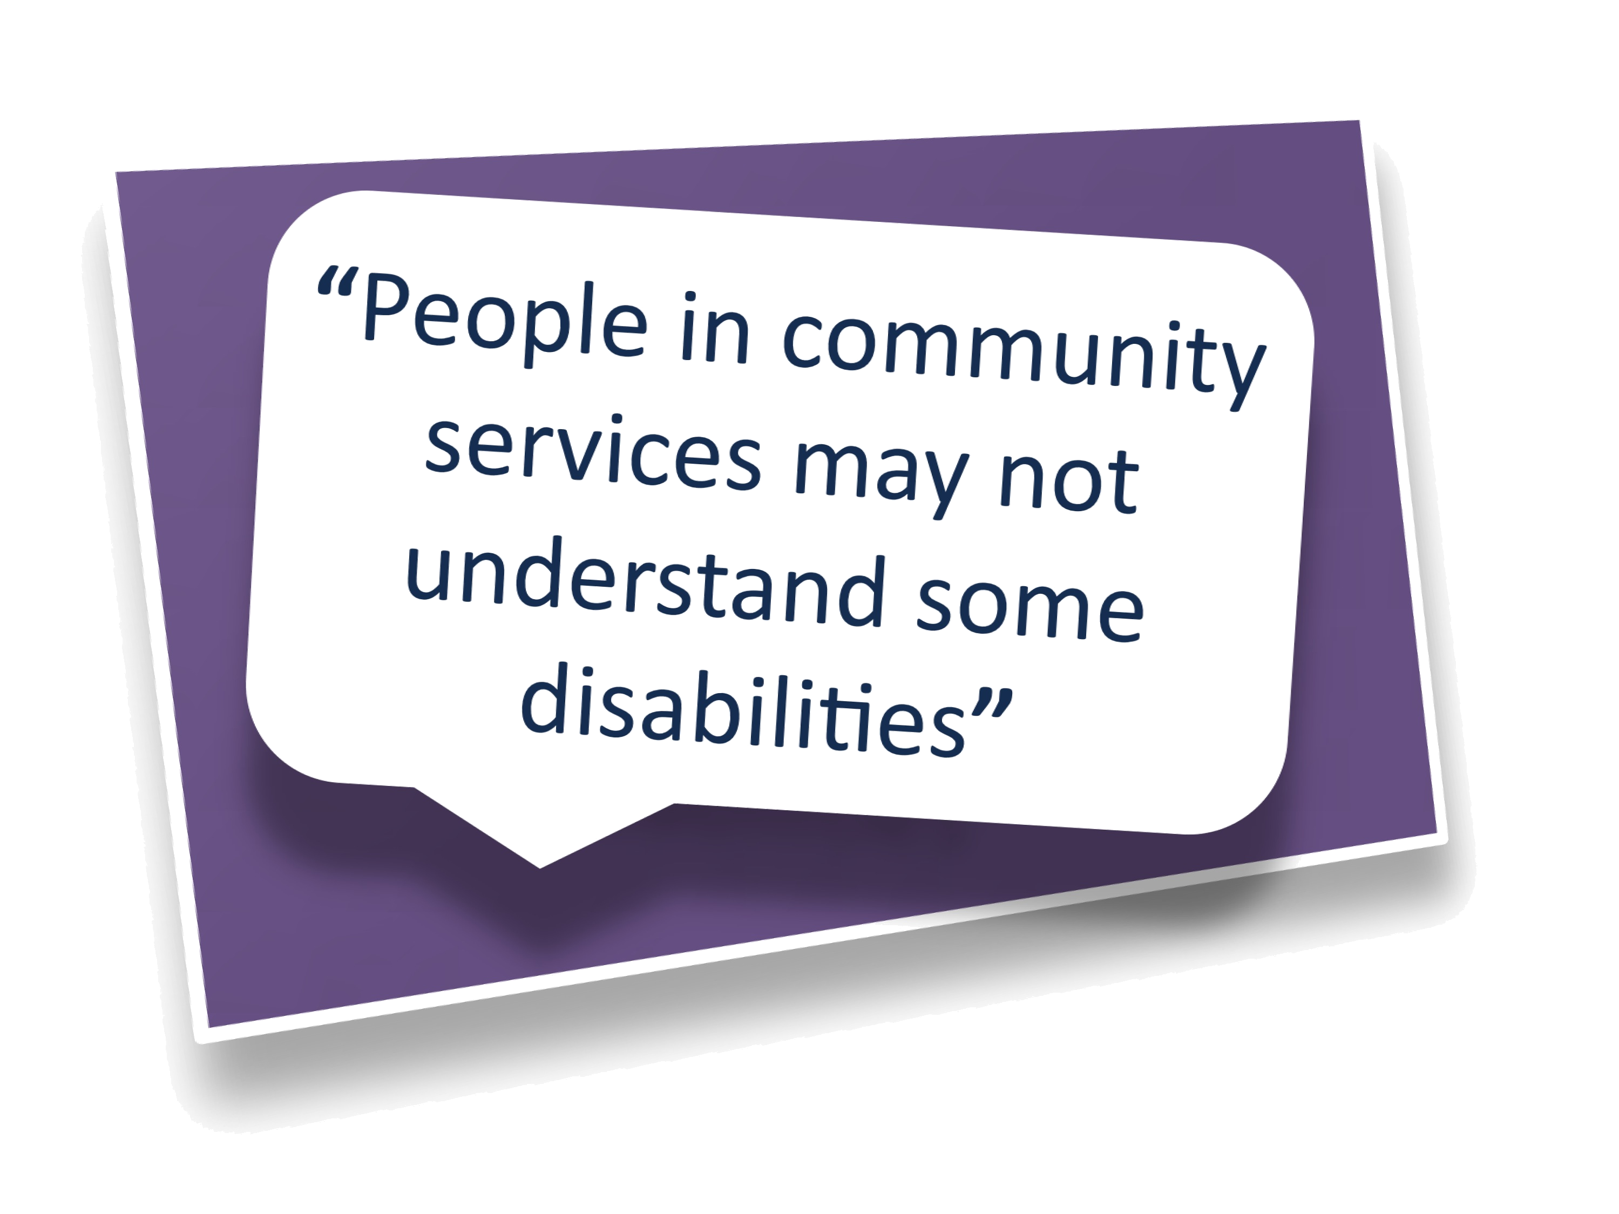

Question 15 of the consultation questionnaire focused on service users who travel outside of the borough in order to access services. Sometimes service users access out of borough services to meet a particularly complex need.

The majority of respondents agreed that encouraging people to access services locally would be a good idea. Other comments included:

- The need for specialist autism services in Harrow;
- People felt that even if they have a higher level of need they should be able to have their needs met in Harrow;
- Some people said they had made friendships in the services they attend and would want to maintain those friendships;
- One respondent stated that people with complex needs should be able to access the community like anyone else and not spend all their time in a building.

Question 16 of the consultation questionnaire asked for views about day centres being used in a different way. This would include mixed hubs for people with a range of needs rather than services specialising in meeting the needs of people with a high level or complex needs. We had a mixed response to the option with some respondents agreeing that as long as the environment was appropriate a mixed ‘hub’ may work well. There were, however, concerns raised that people with behaviour described as challenging or people who are very confused may need specialist support in services specifically focused on meeting these needs.

Just under four out of ten respondents (39%), either strongly agreed or agreed with the proposed model that Harrow Council day centres could be used by lots of different people in the community. A further third (34%) strongly disagreed or disagreed whilst the remaining 27% said they did not know or did not provide an answer.

Additional comments included:

- This model may not suit people with very complex needs who may require specialist support and staffing;
- Staff would need to be sufficiently trained to work with a broader range of needs;
- The model may provide opportunities for greater integration;
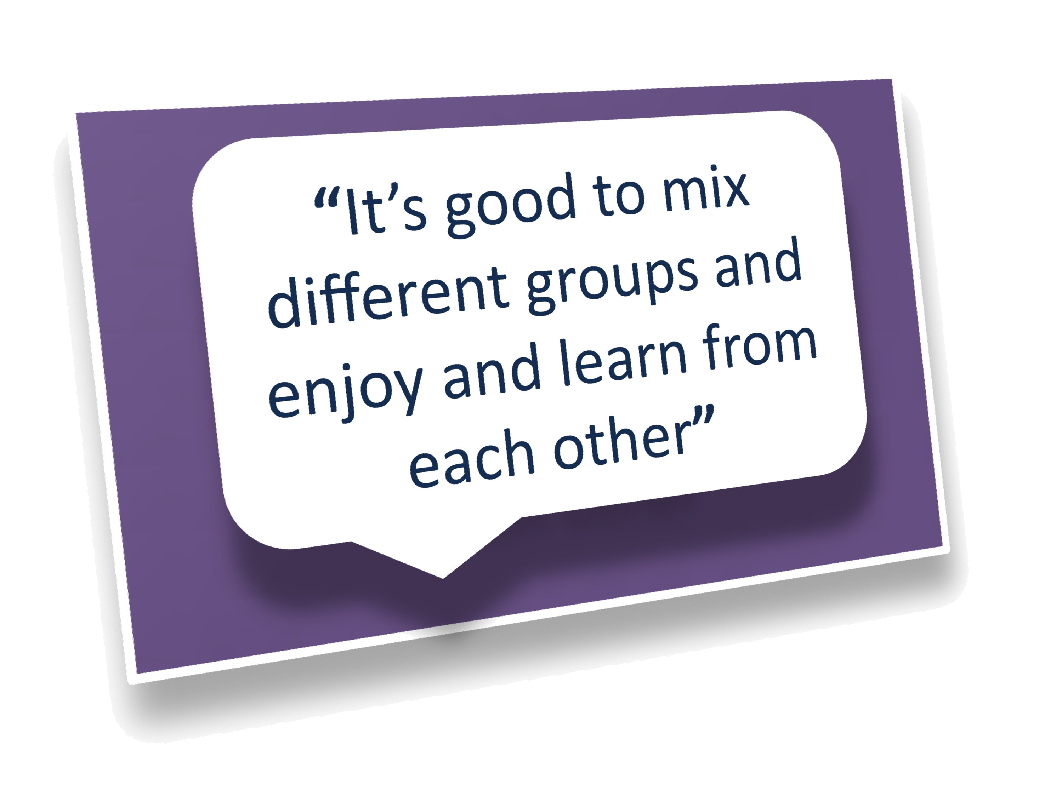
- Any potential safety issues would need to be mitigated.

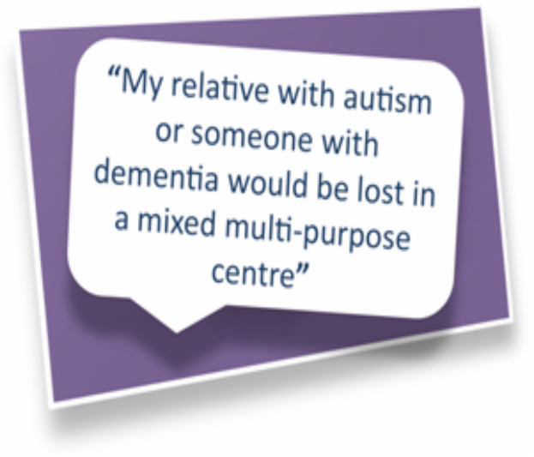

Our response to what people told us
The feedback suggested those who had reservations about the model believed it would mean a cessation of the day service for them and that they will be left isolated. It is recognised that any change can cause anxiety for people. Where anxieties were raised at consultation sessions staff offered reassurance people would not lose the support they needed as they had been assessed as needing support; however services may look different and be provided in a different way.

Staff at consultation sessions confirmed that if changes do take place they would be well managed, may involve a period of transition and would be delivered in a person-centred way. Opportunities would be provided to enable service users and carers to visit centres in advance if an individual was going to attend a different location. Additionally, this may help to address possible concerns where individuals may not have the capacity to consider changes they have not yet experienced.

Discussion took place in consultation sessions about implementation of any proposed change. Service users and carers said changes had to be well planned with individual needs of service users continuing to be met. Many asked for peers within centres and staff to transfer together if changes were being made.

The council needs to make the best use of the resources available to it, and to ensure those with the highest needs are safeguarded from harm and abuse. In a situation with reducing budgets and increasing needs, the council must prioritise the use of specially designed buildings.

However, it is essential people with lower needs are supported to access services as well, and have a choice of high quality, safe activities in the local area. All changes must be as a result of individual needs assessment and person centred support planning. The council will need to ensure people are as effectively safeguarded when using external services as they are when using those provided by the council. Through our quality assurance, safeguarding and complaints processes, Harrow is proactive and committed to ensuring everyone who uses social care services is protected from harm and abuse.

At present 43 (7%) service users are currently accessing day opportunities outside of the Borough. Many people access these services to meet a high level of need that requires a particular specialist service provision. We are proposing to transform the NRCs to meet the needs of people with a higher level of need and therefore reducing the need for people to travel outside of the borough to have their needs met. We recognise people will have friendships they would want to maintain and if a decision is made to transform services in Harrow any changes to people’s services will be done in a person-centred way that will identify where people will need support to maintain existing social networks.

Whilst the idea of a mixed model/hub was favoured by some people, this is likely to be a more expensive option, offering a wider range of services than at present, whilst facing substantial funding constraints. Co-locating some services would be difficult because of the nature of complex needs, meaning that the council is likely to need to provide services in a number of buildings.
We have not proposed a mixed model/hub in the final recommendations to Cabinet. See Section 4.1 on the options considered.

3.3.2 Day Centre Buildings
Questions 13 and 14 the consultation questionnaire:

In consultation we made people aware we are not utilising the day service buildings effectively and many are operating without being used to capacity. We asked people’s views on closing some of the centres to enable the council to use resources more effectively.

What people told us during the consultation
There were 40 (24%) comments on this question; the majority of people did not agree that we should close some buildings in order to maximise the efficiency of resources fearing the building they currently use might close. They indicated in their view there is no suitable alternative to meet their needs, service users need familiarity, and a change in location may not suit some people.

However, during consultation sessions it was evident that people were not familiar with other day centres as they had not visited them. This may have influenced in part their reluctance to consider the efficiency argument of utilising buildings more effectively. Some respondents indicated that buildings should be used fully, and said if centres and transport were more affordable greater numbers of people would attend.

A number of voluntary organisations and groups, including the Harrow Asian Deaf Club use the day centres for meetings and activities. These impacts will need to be considered if there is any reduction in the number of day centre buildings.

Other comments from consultation sessions held at each centre included:

- The importance of planning any building closure was emphasised including helping service users to maintain existing relationships with other service users and staff;
- Family carers of service users at Bedford House Day Centre stated that the centre provided a sense of community for users and carers alike, providing a safe environment;
- Some service users at Bentley said that they would not mind going to a different building if it had the appropriate equipment and trained staff;
- The majority of service users at Milmans stated that they would not mind sharing the centre with other user groups as long as enough trained staff and facilities were available;
- At Byron NRC service users and carers said they wanted to be involved in decisions about the future of their day care provision.

Our response to what people told us
The council recognises change is worrying for people and people often value a familiar environment or a particular place.

However buildings are currently under-utilised and there appears to be a clear case for considering how best to use the centres more effectively. This is a relatively recent phenomenon as when the NRCs were first opened they were well used.

There are a number of reasons why this is no longer the case; many people now access a range of opportunities with a personal budget instead of attending a centre. Most importantly, the impact of the Fairer Charging Policy has led to some people taking the decision not to attend a day centre. They are now being asked to financially contribute to it.

In implementing recommendations it will be very important to ensure that people are given choices about the services they have available, and that the council continues to make provision to meet assessed needs. The council will ensure that people with eligible assessed needs will continue to have their needs met.

The first phase of the transformation of day opportunities in Harrow would be focused on reducing the number of buildings in use and would not result in a change in the level or type of services provided to individuals. Changes to the level or type of service provision to meet assessed need would involve a review of support plans to ensure needs are met. Day services are only one way to meet an individual’s assessed need. If approved by Cabinet, transfer of service users to other centres would be carefully planned in coordination with service users and carers.

3.3.3 What is important about day opportunities
Questions 7 and 8 the consultation questionnaire

In order to effectively plan future day opportunities, we asked about the importance of different aspects of a day activity. Analysis of the responses is included below:

Diagram to illustrate how people rate various aspects of day care provision
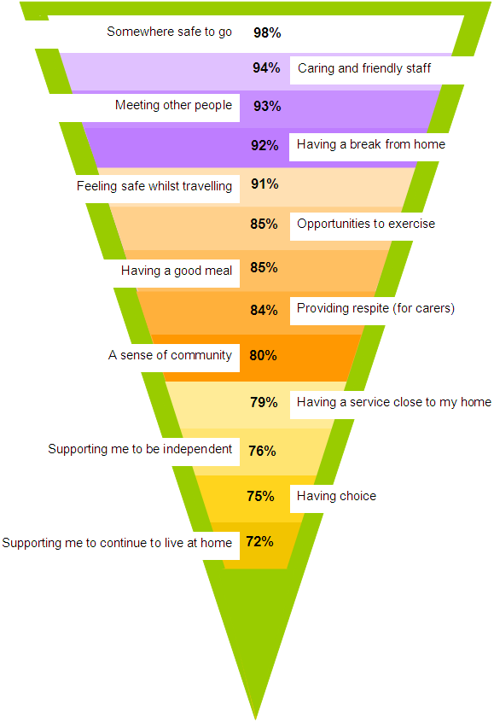

Having somewhere safe to be looked after was considered the most important aspect of day opportunities. Day Centre staff received considerable praise throughout the consultation, which is reflected by the second highest ranking.

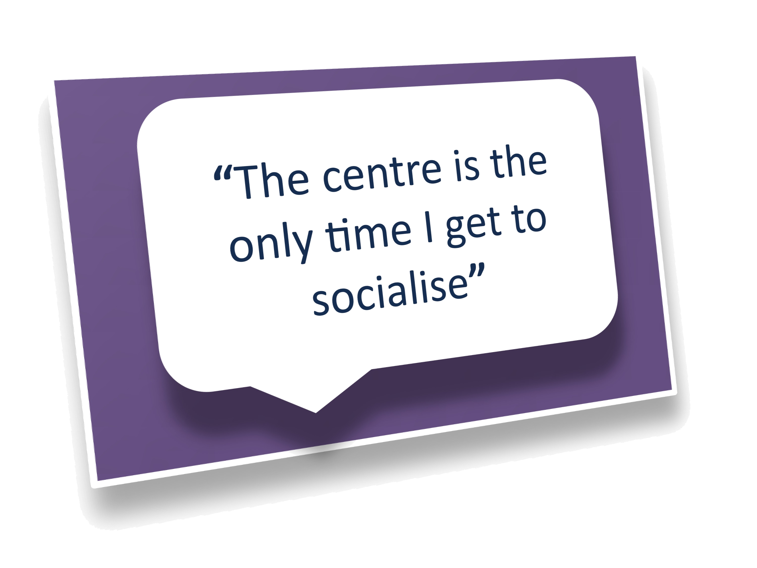
All of the day services/activities were clearly considered to be important, however only 60% of respondents stated work related skills as being

essential, very important or important, which may be a reflection of the number of older people who returned a questionnaire.

Questions 9 and 10 of the consultation questionnaire asked respondents to tick which activities and services they (or the person they cared for) would like to do instead (question 9) and in addition (question 10) to attending a day centre.

In question 9 we asked people to identify the activities they would want to do instead of attending the day centre. Analysis of the responses shows that the most popular activities identified would be going to parks and gardens, shopping trips, day trips, exercise, and cinema.

The activities and services chosen by respondents who answered the questions were relatively similar for both questions. Outings and activities including visiting parks and gardens, shopping and day trips and exercise were the most popular activities chosen by over half of the respondents. Going to places of worship, activities in the pub and alternative therapies were selected by between a quarter and a third of respondents. Some 47% of respondents would like to go to the theatre instead of attending a day centre, whilst 27% of respondents said they would like to go to the theatre in addition to attending a day centre.

Learning and education were important to respondents: 48% would like adult education classes if they did not attend a day centre and 38% would like this in addition to attending a day service. Whilst 47% of respondents wanted to learn new skills if they did not attend a day centre, 50% would like this in addition to attending a day service.

The majority of responses reiterated the important aspects of day opportunities included in the questionnaire. Other comments related to communication with family; carers being part of decision making; affordability; routine; feeling respected; getting help from staff with practical problems like paying bills and learning skills.

A resounding view across all consultation sessions was that service users wanted to get out more and experience different activities. Many people wanted to use the day centre as a central hub or base in order to access a greater range of activities and outings.

Our response to what people told us
These responses help us to identify what is really important to people and what should be considered when transforming day opportunities for them. Additionally, they also help to identify ways of meeting needs in a more creative way rather than in a building-based day service. An example could be where people have rated the importance of having a good meal (73%) - for these people there may be opportunities to identify luncheon clubs in their locality that could provide this element of their support.

3.3.4 Access to Advice and Information
We asked people to tell us how they preferred to a receive information and advice:

- The most popular ways for respondents to receive information were through leaflets and flyers; from voluntary organisations; and through the centres;
- A number of respondents suggested information should be sent by post.

Our response to what people told us
As we develop the market of day opportunities, we will work with voluntary sector partners to ensure information is available on day care activities in the community. Additionally, Neighbourhood Resource Centres provide regularly updated information.

The recent Department of Health User Survey (2012-13) reported a high percentage (71%) of Learning Disability clients and 71% of people with a Physical Disability who found it very or fairly easy to find information. This demonstrates that, in general, people have good access to information and advice.

3.3.5 Views from Voluntary Organisations

Harrow association for Disabled people (HAD)
HAD commented on personal budgets and said giving personal budgets is definitely the ‘way to go’. This may encourage people to ‘gradually replace some of their day service time’. The organisation highlighted that many people rely on their day centres for socialising and do not necessarily want to change.

They felt spending budgets on support into work/voluntary work are positive for many people, as there is currently very limited support available. It is often in the preparation time before work that support is really needed, as it may be provided by Access to Work afterwards if someone finds work.

Moreover, HAD stated personal budgets are a better option to meet the needs of the many people who do not fit into a recognised service model (e.g. people with Asperger’s or Autism), but as with commissioned care, personal budgets may need to be a different and better offer for people who have additional needs. For example people whose behaviour is described as challenging.

HAD cautioned against the suggestion people with complex or a higher level of need cannot access the community and should therefore be in a building based service.

Additionally, they said transport is an important factor for many disabled and older people.

HAD continued to say people may embrace more flexibility regarding their chosen activities “if they weren’t called ‘day activities’ or ‘day opportunities’”. Other people have social lives, lifestyles, etc, and it may not help to develop non-institutional thinking about what’s on offer, if the terms used relate to something which has only ever been offered to people who use services.

Our response
Harrow as pioneers of Personalisation have piloted and are now in the implementation phase of a new solution called My Community ePurse. This will dramatically improve accessibility of personal budgets and lead to a greater choice of services and activities for service users.

We are recommending an option that focuses on NRCs supporting people with the highest level of need. NRCs are staffed by highly skilled staff who are able to support people both in the centre and to access the local community.

Harrow Mencap
In their response to the consultation, Harrow Mencap welcomed the move towards a more personalised approach to the Council’s day service provision. They went on to say ‘where personal budgets are implemented well people have an opportunity for greater choice and control in all aspects of their lives’.

They highlighted the importance of good planning and coordination, particularly where people are experiencing changes to more than one aspect of their support.

They went on to recommend a number of key aspects when considering transforming day opportunities. These included:

- A balance between risks and choice and control;
- Greater access and active participation in the local community;
- A well developed market place;
- Access to information, advice and advocacy;
- A need for more services for older people with dementia, people on the autistic spectrum;
- A need for services to meet Harrow’s ethnically diverse population.

Our response
We welcome Harrow Mencap’s response to the consultation and their support in designing and developing accessible information; and providing their knowledge and expertise to consider the possible impacts of proposed changes to day opportunities.

Age UK Harrow
In their response, Age UK welcomed the opportunity to review the way the day services in Harrow operate. They went on to identify some key aspects to day opportunities for older people including:

- People should have choice regardless of whether they have low level or higher level or complex needs;
- There are still many older people who do not use the internet and need support in this area;
- In the short term closing buildings that are not being utilised makes sense, but be aware of the growing population of older people;
- Many people with a lower level of need do not want to use a day centre;
- Services need to be flexible and be able to respond to people’s changing needs;
- Older people should design their own activities;
- There are not enough activities for older men;
- The model sounds good but people with all needs should have access;
- It would be good to pilot some community hubs.

Our response
We welcome Age UK Harrow’s response to the consultation and their support in designing and developing accessible information.

Their points regarding demographic changes and a potential increase in demand for services are consistent with our recommendations. We recognise the need to retain buildings but must balance this with a vibrant market of community-based activities.

3.3.6 Summary of views from the Provider consultation session
A consultation event was held with a range of provider organisations. The following key points were raised:

- There was recognition that buildings had their place in any new model particularly for people with a high level of need. However support to take an active role in the community is also important;
- There is an increasing need for services for older people with dementia, people on the Autism spectrum and the ethnically diverse population.

Providers’ suggestions for what the market could look like and what they could provide were:

- A larger number of small providers offering services to individuals or small groups;
- A pool of people with skills in a particular activity, like horse-riding, who could work with vulnerable adults on an individual basis, or offer sessions at the day centres;
- Supported breaks;
- Community based support groups for a few hours each week, offering leisure, social skills, independent living skills, sports;
- Flexible transport;
- A job brokerage service, which the service providers and user groups could link into.

Providers suggested ways in which they can contribute to a market of flexible day opportunities. Additionally, they indicated how the Council could support market development through the provision of information, marketing, funding and support with developing models of service.

Our response
Harrow have piloted the implementation of a new solution called My Community ePurse, which will dramatically improve accessibility to personal budgets and lead to greater choice of services and activities for service users.

We are recommending an option that focuses NRCs on supporting people with the highest level of need. NRCs are staffed by highly skilled people who are able to support people both in the centre and to take an active role in their local community.

3.3.7 Staff Views
Staff meetings were held at each of the NRCs and internal day services during the consultation period. Staff identified the following key points:

- Specialist training where necessary;
- To have up to date information so that they are able to support service users effectively if they have any questions;
- More information about the recommended option and what it means for individual staff.

Unions were invited to attend all staff meetings. A Union representative has been present at staff meetings and their views have been incorporated into the staff feedback. Their specific comments and questions included: the breakdown of the efficiency target; confidence the changes would achieve the target; risks to jobs and working conditions; importance of considering role profiles; covenants which restrict sale of buildings; and having sufficient time to respond to the cabinet report before a decision is made.

Our response
Staff were informed that the aim of the meetings was for informal staff engagement to enable their views to be fed into the consultation process. If a decision is made necessitating changes to staff roles and responsibilities a formal consultation will be carried out in accordance with the Council’s Protocol for Managing Change.

We appreciated the Union’s attendance at the staff meetings both for the support they provided staff and the additional questions they asked. A written response has been sent to the Union on the points they raised. The Unions will be provided a copy of the Equalities Impact Assessment (EqIA).

3.3.8 Feedback from Harrow Clinical Commissioning Group
Harrow Clinical Commissioning Group (CCG) submitted the following response to the consultation:

Harrow CCG wishes to work with the Harrow Local Authority in the development of the proposed model for Adult Day Services. This will maximise the shared opportunity to support greater integration of health and social care services in order to develop improved, seamless, preventative services.
There are significant opportunities for alignment and collaboration between health and social care in the development of Adult Day Services.
This is reflected in a number of strategic Harrow CCG priorities and specific areas of work underway, which would be relevant to the Adult Day Service Review, including: The Out of Hospital Strategy: ‘Shaping a Healthier Future’; the Joint Health and Wellbeing Strategy 2013 – 2016; and the: local Quality, Innovation, Productivity, and Prevention (QIPP) Programme.
Other areas of synergy between Harrow CCG and Harrow Council with regards to Adult Day Services include:
- Harrow Council and CCG Joint Commissioning Intentions for 2013/14, i.e. winter planning, dementia, and Children’s Services (particularly where we can support alignment of the health and social care services supporting service users as they transition from children’s to adult services).
- Winterbourne View: ensuring that adult safeguarding is strengthened in line with national recommendations.
- Joint NHS Harrow and Harrow Council Autism Strategy: including improving the support offered to the known population of people with autism, including people who have autism with additional learning disabilities or mental health issues.
Harrow CCG welcomes the consultation and review of Adult Day Services in Harrow, and hopes to work closely with the Council to develop proposed models in order to:
- Maximise opportunities for integration between health and social care services; and
- Ensure alignment with existing health and social care strategies.

Our response
The council welcomes this helpful and constructive response from the CCG, which is in line with feedback from users of day services who wished to see the integrated service delivery.

Section 4.3 of this report sets out the different phases of implementation of recommendations, should they be accepted. We will seek to work closely with the CCG lead up to, and during implementation of Phase Two, to identify opportunities to provide integrated support within the future service model. This will include potential for capital works to support this integration as outlined in Section 5.2.1. A representative of Harrow CCG will be invited to be part of the Implementation Group for this review.

3.4 Key conclusions & messages from consultation

This section includes a summary of the key messages we have taken from the consultation. These have been reflected in our considerations in relation to options:

- Service users and carers emphasised the importance of day care/day opportunities;
- Service users and carers understood the need to rationalise the use of buildings;
- Service users identify with a particular building and service and whilst there was a recognition some buildings may need to close, people did not want the service they attended to close;
- Respite was seen as an important element of independent living enabling carers to continue to support service users within their own homes;
- Integration with Health and access to health services such as physiotherapy were seen as positive;
- Personal budgets are key to choice and control and people need support to understand the process;
- Personal budgets, are considered a better option to meet the needs of the many people who do not fit into a recognised service model;
- The introduction of the Fairer Charging Policy has affected attendance at the day centres;
- There is a need for services able to support people with dementia, autism and behaviour described as challenging;
- Buildings are important but so is taking an active role in the community;
- People will need good information and support if a decision is made that leads to change.

Section 3.5 Capital/building considerations

Alongside the consultation, research and analysis of data, the availability and use of suitable buildings is a key consideration in determining a future model of day opportunities. We have identified both in the January report to Cabinet, and earlier in this report that we expect to use fewer buildings in the future than at present.

The table below (and a more detailed table in Appendix C) sets out information about the seven buildings that provide Harrow run day opportunities and the block contract delivered at Sancroft Hall. The table includes details of capacity, accessibility, ownership and Pros and Cons in relation to the continued use of the building. This information will be used to help to identify services we should use in our future service model.

In this section, we are considering how suitable each building is for the delivery of services in this review. In doing so, we need to consider the ownership and contractual arrangements of the buildings, and whether the council is able to make alternative use or dispose of them. A key consideration in this is, for example, where PFI arrangements are involved the council would need to enter into detailed and potentially expensive arrangements for alternative use or cessation of the agreement.

We will discuss capital considerations again in a later section (Section 5.2.1) of the report in which we consider the impacts of recommendations. This section will consider changes, which would be needed to buildings we are recommending to use in the new model.

As outlined in the table below, the Council owns Bentley and Bedford House with no restrictions on use. In addition, Milmans is council owned. However, this has a covenant on it limiting the types of activities it can be used for. This covenant is likely to reduce the commercial value of the land and its attractiveness to investors.

Name | Current Use | Capacity | Accessible? | Owned by | Pros  (for future use) | Cons  (for future use)
Bentley Harrow Weald | People with Physical Disabilities | 64 | Yes | London Borough Harrow | - Large site  - Large capacity  - Gym on site  - Large number of voluntary sector groups use building | - Run-down building  - In need of modernisation  - Prime location for sale
Bedford Pinner | People with Learning Disabilities | 9 | Yes | London Borough Harrow | - Good facilities on site | - Small capacity  - On site of residential home
Milmans Pinner | Older People including Dementia | 50 | Yes | London Borough Harrow | - Covenant on building use  - Good location in desirable area | - Some improvements needed
Sancroft | Older people, focus on BME groups. 1 Learning Disability session | 50 | Yes | Catalyst Housing | - Long-term contract for use  - Modern, high spec building | - Need to negotiate model
Gordon Avenue Stanmore | People with learning disabilities | 9 | Yes | Genesis | - Good location | - Small capacity
Byron Weald-stone | People with learning disabilities | 40 | Yes | London Borough Harrow | - Modern, high spec building  - Tied in to PFI | - Need to negotiate changes
Vaughan West Harrow | People with learning disabilities | 30 | Yes | London Borough Harrow | - Modern, high spec building  - Tied in to PFI  - Has a multi-sensory environment | - Need to negotiate changes
Kenmore Kenton | People with learning disabilities | 30 | Yes | London Borough Harrow | - Modern, high spec building  - Tied in to PFI | - Need to negotiate changes

Byron, Kenmore and Vaughan are council owned but subject to a PFI agreement. There is a financial commitment from the council to continue to pay for these buildings until 2024. The council could potentially negotiate alternative uses for these buildings, however they are purpose built for delivering services to adults with disabilities, and physical changes would incur additional capital costs.

We have not considered factors relating to the secondary uses of buildings, such as use by Voluntary Sector groups in this part of the report. These are referred to in Section 5.2 where we consider capital implications of recommendations.

These capital considerations are factored into the proposed models and recommendations in Section 5.2.

Section 4: Service Models & Recommendations

4.1 Service Model Options

This report has considered a wide range of information, which supports decision making in relation to the future model of day opportunities. This includes the Why a change is needed, feedback from Consultation, Capital considerations and the needs that the council must meet.

The report identifies the need for a new and coherent model of services with the aim of transforming “day services” to “day opportunities”. In the consultation we asked a range of questions about the way we use the day centre buildings and how we might change the way the services are provided in the future. Officers have sought to identify the options, which would meet the objectives of the review and achieve the outcomes identified as most important by users and carers. This would be through the provision of high quality services within the available budget.

The drivers for change identified through consultation and analysis include:

- A number of the internal services are operating significantly under capacity, identifying a need to reduce capacity in some areas
- Benchmarking data shows that a high number of people use day services and that some of these are relatively expensive compared to other areas
- In future an increasing number of people who have complex needs, including dementia, will need services
- The council is committed to continued use of a number of buildings, through contractual arrangements, but has more flexibility in others
- The council needs to achieve savings, as set out in the Medium Term Financial Strategy, and so there is a need to make changes to the way services are delivered
- Over time the impact of Personalisation will be that more people need to be more able to make choices about how they wish to meet their needs – the services we provide need to reflect this
- Consultation identified a need for services able to support people with dementia and autism and behaviour described as challenging
- Service users and carers understood the need to rationalise the use of buildings

Following the consultation officers have identified there to be three broad options relating to council provided services for Cabinet to consider:

- Retain all seven internal day services and buildings (no change);
- To change the NRC service provision to focus on meeting the needs of people with high level or complex needs. In doing this deliver services from Byron, Kenmore, Vaughan and Milmans NRC’s, but close Bentley NRC, Gordon Avenue Day Service and Bedford House Day Service;
- Provide a mix of Community Hubs and Specialist Services, either co-located or provided in different buildings in the borough.

In all options we will need to work with the owners and providers of Sancroft Hall to maximise the contract we have with them. This work has already started. The council does not own or run this service but has a PFI contract with them, which still has 12 years to run. The day services at Sancroft Hall are currently running significantly under capacity.

The options have not included details of how Personal Budget funded external services will operate in the future. This is because these services are commissioned by individuals, rather than the council. Cabinet does not have authority over the way they operate. However, through our market development work, officers will work closely with service users and providers of services ensuring there is an effective market place of services to meet needs. This will be facilitated through My Community ePurse.

Evaluation of the options considered has been outlined below:

Option 1: Retain all seven internal day services and buildings (no change)

Description
Services would continue as they are now. They would provide support to the current service users who access them.

Retain all services and buildings - Bentley NRC, Byron NRC, Kenmore NRC, Vaughan NRC, Milmans NRC, Gordon Avenue Day Service and Bedford House Day Service.

Analysis
- Maintaining all the services without change would mean continuing to provide services to a reducing number of service users. This is whilst other people use their personal budget to access activities outside of the council provided services. This would effectively result in additional costs;
- Day centre buildings would continue to operate well below their available capacity;
- The consultation suggests this would be the most favoured option by the majority of service users and their carers. This may be because change can be difficult for some people to consider. However, a number of consultees welcomed the opportunity that change may bring;
- People with very complex/high level needs may still have to travel outside the Borough to access their services;
- The council will not be able to respond to the changing demographic demand in the borough. This includes the increase in number of older people with dementia who require support and young people with autism and severe behavioural challenges;
- The council will continue to provide services to focus on both those with the highest needs and a wider range of vulnerable people. However, carers indicated in consultation that many service users with complex needs would not be able to receive day care alongside other client groups. This is due to specific types of support needed and possible challenging behaviour of service users;
- Maintaining the services as they are now would not achieve the MTFS efficiency saving of £300k in 2013-14 and £300k in 2014-15;
- The council would need to purchase services elsewhere to meet the needs of those people with the highest support needs, resulting in additional costs in providing support.

Option 2: To change the NRC service provision to focus on meeting the needs of people with high level or complex needs. In doing this deliver services from Byron, Kenmore, Vaughan and Milmans NRC’s, but close Bentley NRC, Gordon Avenue Day Service and Bedford House Day Service

Description
Bentley NRC, Gordon Avenue Day Service and Bedford House Day Service would close. Service users would transfer to other day centres including Kenmore, Byron, Vaughan, Milmans and Sancroft Hall.

The level (number of days attendance) and type of activities would be maintained, therefore the initial change for service users will be the building/location.

Running costs would be saved and posts including, vacant posts, restructured. This will deliver efficiency savings assuming wider redeployment opportunities across the council.

Once the three buildings have closed and service users have moved, work will begin to review people to identify those who could be supported to access services in the community via a personal budget. This would be by using My Community ePurse - a tool which would dramatically improve the accessibility of personal budgets and lead to greater choice of services and activities for service users.

The buildings continuing to deliver services would be refocused to deliver specialisms in the following ways:

- Specialist day activities for older people, including dementia;
- Specialist day activities for people with physical disabilities;
- Specialist day activities for people with a learning disability autism/challenging behaviour;
- Specialist day activities for people with a profound and multiple learning disabilities including sensory.

Analysis
- Buildings are currently under utilised. Efficiencies would be achieved through reducing the number of buildings from seven to four in respect of running costs and the deletion of a number of posts;
- People with the highest level of need would be able to access specialist services in the borough. Staff would be trained to work with people with complex needs who would be supported to achieve improved outcomes and be able to access services locally;
- People with lower level needs would be supported to exercise choice, control and achieve better outcomes by using personal budgets to purchase activities they enjoy from a market place of opportunities;
- This option would achieve the MTFS efficiency saving of £300k in 2013-14 and £300k in £2014-15;
- This would support achievement of efficiencies through rationalising the services to focus on those with highest needs. Council buildings have been purposely designed to support people with complex needs – facilities not needed by other groups;
- This option would support demographic challenges, for example by ensuring capacity for people with complex needs transitioning to adult services;
- Supports the localism agenda by encouraging the use of third sector, and alternative local providers;
- Many consultation responses positively welcomed the provision of specialist services and development of a market of alternative providers for people with lower level needs;
- A number of people with lower levels needs who use the NRCs and building-based day services would need support to identify alternative options to meet their assessed needs.

Option 3: Provide a mix of Community Hubs and Specialist Services, either co-located or provided in different buildings in the Borough

Description
This model would provide a service offering open access regardless of FACS eligibility. There would be a drop-in type service alongside specialist and intensive models of support for those with complex needs.

This would enable a larger number of people to access services, advice and information without the need for a formal assessment. This is likely to increase the costs of running the service as staffing levels would need to match those in Option 2, but with the addition of support to a large number of additional people.

These services could be co-located in the same building, or in separate buildings, dependent upon capacity and location.

Analysis
- This would enable council services to focus on both those with highest needs, and a wider range of vulnerable people. The Council would need to consider safety issues for providing services in this way;
- During consultation, clients from all groups said they would like to mix with other client groups and previous experiences had been positive;
- This is likely to be an expensive option, due to the need to provide staff, offering a wider range of services than at present, whilst facing substantial funding constraints;
- Co-locating some services would be difficult because of the nature of specialist support for complex needs. This means the council is unlikely to be able to rationalise the number of buildings that services are provided from;
- Carers indicated in consultation many service users with complex needs would not be able to receive day care alongside other client groups due to particular needs and possible challenging behaviour of service users;
- It is very likely this option would result in a loss of income as people would opt for open access, free-of-charge services, rather than those for which they are financially assessed and need to contribute.

4.2 Recommended Option

After careful consideration of the options, it is suggested that Option 2 will be the most effective way to meet the objectives of this review. This option is for Harrow Council’s internal service to focus on those with the highest level of needs.

In summary, the option is to retain the following for use as day opportunities:

- Byron NRC
- Kenmore NRC
- Vaughan NRC
- Milmans NRC

But to cease to use the following:

- Bentley NRC
- Gordon Avenue Day Service
- Bedford House Day Service.

The recommendation is through a phased period of transition. Officers would work to change the delivery within Neighbourhood Resource Centres so they have a greater focus on meeting the needs of people with high level or complex needs.

In accepting this proposed service model, Cabinet would be agreeing to confirm the nature of internal day services to meet the needs of those with highest needs in Harrow.

The bases for this recommendation are:

- The council needs to ensure we are able to support those most at risk, despite the challenging financial climate we are in. This option ensures we are focusing on the group most in need;
- This model provides the best use of limited funds to ensure we meet assessed needs. This will support the delivery of efficiency savings;
- The council’s NRC buildings have been purpose built to support those with the highest needs. This includes equipment and specialist design, which is not needed by the more able;
- Further development of the market of activities and services for people with lower level needs will facilitate and support local community and voluntary sector developments;
- The council has a duty to support people to be as independent as possible. Supporting people more able to access services in the community is part of achieving this aspiration.

4.3 What this means in practice

Implementing these recommendations would involve a substantial amount of change in day opportunities in the Borough and will impact upon the people who use them.

A key aspect the council must consider is in ensuring the assessed social care needs of those receiving services can be met in the new arrangement. This section outlines how we will ensure we can do this.

A priority will be meeting the needs of people attending Bentley, Gordon Avenue Day Service and Bedford House Day Service, as these services will be the most affected. Their needs can still be met in the remaining four NRCs and Sancroft Hall.

In delivering the changes recommended in this report, the council will adopt a two phase approach:

The first phase of the implementation will be supporting service users of Bentley, Gordon Avenue Day Service and Bedford House Day Service to access services within the four remaining NRCs and Sancroft Hall. This will mean at this stage, services continue to support the same group of people to those supported at present, but in fewer buildings.

This approach will ensure affected service users continue to have their needs met, and are able to be supported within the buildings we continue to utilise. These changes would deliver the £300k MTFS saving in 2013-14 and would address the under-utilisation of the day centre buildings.

The second phase involves changes over a longer period of time. Through individual needs assessment and support planning, a number of more able people using services would be supported to access community based support options with through personal budgets. These moves would in turn create capacity within day services to respond to demographic changes and support people with complex needs coming through transition, or currently supported away from the borough.

4.3.1 Phase One - Reducing & Rationalising Buildings
In this phase we would support the service users at the following services to move to one of the other day centre buildings:

- Bedford House Day Service;
- Gordon Avenue Day Service; and
- Bentley Neighbourhood Resource Centre

Following these supported moves we will cease to deliver day opportunities from these buildings. See section 5.2.1 for information about capital implication of these moves.

The information below demonstrates there is enough capacity across the remaining building/services to enable service users to be accommodated. All of the retained buildings are of a high standard; Disability Discrimination Act compliant; and fully accessible. Service users moving from one building to another would continue to receive the same level of support as they currently do.

It is important to note that changes to the retained services, notably a change of client group in Kenmore, would mean some service users in the retained NRCs may also need to move between services.

All moves would be carried out sensitively. Officers will seek to support people to move in friendship groups to support transition. Wherever possible, staff will move with service users in order to ensure continued support and a smooth transition. In this way the council will ensure staff are able to continue to provide the appropriate level and type of support.

Capacity within Council Day Care Centres
The table below shows the capacity and the planned day places at each of the three day centres recommended for closure and transfer. For example, at Gordon Avenue there is a daily capacity for 9 places which, over a working week, is a capacity of 45 day places. The column ‘current planned day places’, is based on the actual planned figures for all service users who were expected to use the services during February 2013.

The table shows the need to transfer 170 day care places per week.

Day Service | Capacity per day | Capacity  per week | Current Planned day places  (i.e.: no of day places allocated each week) | Utili-sation | Recommendation
Gordon Avenue Day Service | 9 | 45 | 30 | 67% | Close & Transfer
Bentley NRC | 64 | 320 | 99 | 31% | Close & Transfer
Bedford Day Service | 9 | 45 | 41 | 91% | Close & Transfer
Number of weekly day care places to transfer |  | 410 | 170

The table below shows the available weekly capacity in the remaining five day centres (4 NRCS and Sancroft). The table shows the available capacity is 285 day care places per week.

Day Service | Capacity per day | Capacity  (i.e. no. of day places available each week) | Current planned day places*  (i.e.: no of day places allocated each week) | Available Capacity  (capacity minus current planned day services)
Byron NRC | 40 | 200 | 150 | 50
Vaughan NRC | 30 | 150 | 151 | -1
Kenmore NRC | 30 | 150 | 137 | 13
Milmans Day Centre | 50 | 250 | 124 | 126
Sancroft Day Centre | 50 | 250 | 153 | 97
Total |  | 1,000 | 715 | 285

The table below sets out the number of weekly places that need to be transferred against the available capacity in the remaining five day centres.

Number of weekly day care places to transfer as a result of the closure of three Day Centre Buildings | 170
Available capacity in the remaining five Day Service in the new proposed model | 285

The table demonstrates there is considerable capacity across the Council’s current day care facilities. The proposed closure of three centre buildings and transfer of these services in a phased plan can be accommodated within the remaining centres and the Sancroft contract. This will ensure that we can provide value for money and continue to meet assessed day care needs for clients currently attending our centres.

As can be seen in the table, there will continue to be some capacity once the three buildings have closed. This capacity is both helpful and necessary, in order to facilitate the transition of changes in Phases One and Two, and to help to deal with demographic change and increasing complexity of needs.

The potential impacts of these changes and how we will work to mitigate these are explored in Equalities Considerations later in the report.

4.3.2 Phase Two – Longer Term Changes to Delivery in NRCs
In this phase, Officers would seek to implement changes to the way NRCs operate so they can support more people with complex needs, whilst supporting more people to access services in the community.

Phase Two will involve market development work, and working with other community services to increase choice. We will seek to support more people to access activities in the community by working with voluntary and independent sector organisations.

As part of this, we will ensure high quality information and advice is available ensuring service users know about community services, including information about the range of clubs and activities available.

In addition, work in partnership with the Council’s Community and Culture department will facilitate access to a diverse range of opportunities, which could include:
- Sports Development and West London Sports Alliance: Greater use of sports facilities and accessing grants to offer programmes to people with disabilities;
- Arts Centre: tailoring sessions and activities to meet the needs of older people and people with disabilities;
- Libraries: Reading groups, regular tea/coffee mornings, on-going gardening projects;
- Allotments: dedicated gardening programmes.

Developments through Public Health programmes will also contribute significantly to the Prevention agenda.

The next section of the report explores these changes and the way services would operate in the future.

4.4 Future Service Delivery

In this section, we identify the model of delivery in the buildings we are recommending to deliver day opportunities from in the future.

What services do we need?
Based on the recommended option and information about needs and current usage of services earlier in this report, we have identified a need for the services below.

The numbers of units are estimations based on existing use, demography and strategic direction. Due to individual choice and the impact of personalisation, we are not able to determine an exact figure for the number of units we will need. However, we can be sure the provision of the following will ensure Harrow Council is able to continue to meet assessed needs:

A. Specialist day activities for older people, including dementia - Equivalent to 250 days per week = 50 places each day

B. Specialist day activities for people with physical disabilities - Equivalent to 150 days per week = 30 places each day

C. Specialist day activities for people with a learning disability - Equivalent to 300 days per week = 60 places each day. This includes approximately 150 days (30 places each day) specialising in supporting people autism/challenging behaviour, and 150 days (30 places each day) specialising in support to people with health and physical disabilities.

Building Options for delivering these services

A. Specialist day activities for older people, including dementia – approximate need identified is equivalent to 250 units/50 units per day.

- There are two buildings currently supporting older people and which have sufficient capacity to host this service. They are Milmans and Sancroft;
- Milmans currently supports vulnerable older people and has a covenant restricting the way the building can be used;
- Sancroft Hall is a PFI contract, which still has 12 years to run (ends 2024). This already supports older people with a range of complexities.

Proposal: Milmans and Sancroft will both play a role in meeting the needs of the growing population of older people with complex needs. They are both currently supporting older people and the environment is suitable at both centres. In the short-term, there will continue to be capacity within both services. Phase 2 of the implementation of recommendations will include development of options to increase use of facilities by partners, such as the health service to target interventions that support health and wellbeing.

B. Options for specialist day activities for people with a learning disability autism/challenging behaviour - approximate need identified is equivalent to 150 units/30 units per day.

- Byron, Vaughan & Kenmore are agreements under PFI contract, and need to be used in the new model as the council has continuing payments for them. They are purpose built and fully accessible;
- Byron has outdoor space, which is essential for supporting people with challenging behaviour;
- Byron is next door to Harrow Leisure Centre, which is helpful in providing exercise-based activities for some service users with autism who have with high levels of energy.

Proposal: Byron is recommended due its outside space and its proximity to Harrow Leisure Centre.

C. Options for specialist day activities for people with a profound and multiple learning disabilities including sensory - approximate need identified is equivalent to 150units/30 units per day.

- Vaughan has a multi-sensory room on site. People already travel from Kenmore NRC to use it;
- Vaughan and Kenmore are agreements under PFI contract, and need to be used in the new model as the council has continuing payments for them. They are purpose built and fully accessible.

Proposal: Vaughan is recommended as, in common with all other NRCs, it is fully accessible. Additionally, Vaughan has a multi-sensory room, which will be essential for people with sensory needs.

D. Options for Specialist day activities for people with physical disabilities - approximate need identified is equivalent to 150 units/30 units per day.

- This service needs an accessible building with capacity to support up to 30 people per day;
- The building has space and is able to accommodate a gym – an aspect which has been identified as essential by service users at Bentley Day Centre.

Proposal: Kenmore is recommended as it is modern, has a high specification, is fully accessible and has space for a gym.

Section 5: Implication of Recommendation

5.1 Legal implications

The proposals being made to the Council’s Cabinet are ones governed by a range of statutory requirements, which set out the services the council must provide. When changing service provision, as well as complying with statutory requirements, the Council must make its decision in a fair way to ensure it complies with its public law duties.

5.1.1 Provision of services
The council has a legal duty to continue providing support to people using the services in this review, based on an assessment of their needs. Within recommendations for changes to services, the council will continue to ensure high quality care and support is available to all users, based on an up to date assessment of needs and the development of a support plan .The council will work closely with carers to ensure that their needs continue to be met, as a result of any change to service.

Under s.29 of the National Assistance Act 1948, eligible persons are entitled to prescribed non-residential welfare services. At paragraph 29 2(1)(c), local authorities are directed to provide, whether at centres or elsewhere, facilities for occupational, social, cultural and recreational activities. This can include day centres, workshops, recreational and educational activities, as well as facilities for art, sport and drama.

Additionally, there is a duty under s.2 of the Chronically Sick and Disabled Persons Act 1970 to provide some non-residential services to those who are assessed as eligible. These include recreational services and educational facilities.

The eligibility for both s.29 National Assistance Act 1948 and s.2 Chronically Sick and Disabled Persons Act 1970 services are the same: persons aged 18 or over; who are blind, deaf or dumb; or who suffer from mental disorder of any description; and other persons aged 18 or over who are substantially and permanently handicapped by illness, injury or congenital deformity.

In addition to the above, the council should have regard to the European Convention on Human Rights when making changes to services. In particular, the council must ensure proposed changes do not infringe Article 3, which relates to “inhuman or degrading treatment or punishment”. In addition, Article 8 relates to the need for people to have the “right to respect for private and family life”. The Human Rights Act requires an authority to consider whether its action could interfere with an individual’s rights as set out in the European Convention on Human Rights and in certain cases where the right is qualified, consider what legitimate interest it is seeking to achieve and whether the interference is proportionate to this legitimate aim. It is not envisaged that this decision will infringe Article 3 or Article 8.

The Equality Impact Assessment has identified potential impacts on vulnerable groups. However, it is clear that none of these impacts could be considered to infringe either Article of the Human Right Act.

5.1.2 Process for arriving at a decision
When deciding to change the way a service is provided, the Council must take account of all relevant information, including financial resources; consultation responses; and potential equality impact in order to reach a decision. Cabinet are obliged to consider the Council’s overarching statutory duties, for example its equality duties, when taking decisions to change the way a service is provided.

The Council has carried out a consultation process to seek the views of stakeholders and users of the services. Members must feel confident this there has been an appropriate level of consultation and reasonable efforts have been made to involve relevant parties. Summary details of the consultation responses have been set out in the main report and in more detail in Appendix B. Full details of the consultation responses are available as background papers. Case law has confirmed when determining whether to change service provision, the Council must be receptive to reasonable arguments against the proposals. However, this does not simply involve a head count of those for and against the proposals. The Council must take all views into account, as well as other relevant information. Even if the respondents to the consultation have strong views against the proposals, Cabinet may decide to introduce the proposals if justified for proper policy and operational reasons.

In relation to questions of capacity of individuals to make decisions, the consultation was not asking consultees to make a firm decision about their services. It was seeking their views on potential changes to the way in which services are provided. In this paper, no decision is being made in respect of any individual's care package or provision. The Mental Capacity Act 2005 presumes that a person has capacity unless that presumption is rebutted. The Act provides for best interests decisions to be made where a person lacks capacity to make a specific decision and sets out the process for making such a decision, which will include the involvement of relevant family friends and carers. In this consultation, no specific decision is being proposed for service users.

Case law has confirmed that when consulting with people who may lack capacity the Local Authority has to make all reasonable efforts to engage service users, but this is likely to be a challenging and less than perfect exercise. However, if done responsibly it will be unlikely to invalidate the consultation. In this consultation various methods of engagement have been used, involving skilled workers, and those who knew service users (including family, friends and carers) and were involved in trying to elicit views.

The Public Sector Equality duty created by s149 of The Equality Act 2010 requires a public authority to have due regard to the need to:

a) Eliminate discrimination, harassment, victimisation and any other conduct prohibited under the Act;
b) Advance equality of opportunity between persons who share a protected characteristic and persons who do not share it;
c) Foster good relations between persons who share a relevant characteristic and persons who do not share it;
d) Protected characteristics include age, disability, race, religion or belief and sexual orientation.

The Public Sector Equality Duty is a continuing duty and must be taken into account when the Council is making decisions about service provisions, which may potentially impact upon service users with protected characteristics under the Act.

The Mental Capacity Act 2005 presumes people have capacity to make their own decisions unless the presumption is rebutted. Where there are reasons to believe a service user may lack capacity in respect of a particular matter, an assessment should be undertaken in accordance with the Mental Capacity Act 2005. If an individual is assessed as not having capacity to make a specific decision, then it may be necessary for a best interests decision to be made in accordance with the Mental Capacity Act 2005 requirements.

When making changes, the Council must take account of the equality duty and in particular, any potential impact on protected groups. This report outlines the potential impacts on vulnerable people of the recommendations included – these are set out in Section 5.7 and in the Equality Impact Assessment (Appendix D).

The recommendations in this report take account of the feedback received from service users, family members, advocates, staff and unions. The equality duty requires the council to have “due regard” to impacts, and to consider mitigations where impacts are expected. This does not mean changes cannot take place where there will be an impact.

This report presents options and a recommended option. However, this does not preclude Cabinet from determining another option being the most appropriate way forward. In an extreme case, if Cabinet felt the severity of impact of the proposed options on particular groups of individuals, was such that none of the options are appropriate, and additional resources are required to fund these services, then it should refer the matter up to full Council with a recommendation that further spending resources be allocated to the Directorate (either from Council reserves or from other budgets).

5.2 Financial Implications

5.2.1 Capital
Capital considerations have been an important factor in developing final recommendations. Approval to implement recommendations would mean that Bentley Day Centre, Gordon Avenue Day Centre and Bedford House Day Centre would not be used leading to options including potential disposal for the council.

Bentley Day Centre – this asset would no longer be needed and could be considered for disposal by the council. As part of the Council’s Medium Term Financial Strategy it was assumed £2m capital receipts would be achieved for non-specific sites. The disposal of this property would support the delivery of these assumptions. The Council has been approached by a commercial developer interested in this site. A further Cabinet decision would be needed if the council wished to dispose of the site.

Gordon Avenue – this is not owned by the council. Officers would need to agree arrangements for ceasing lease terms with the owners. Further work is required to establish whether there will be any costs associated with the cessation of the use of this property (i.e.; security, dilapidations etc), though these would be incurred at some stage when the property is finally handed back.

Bedford House – we have outlined in a separate Cabinet paper we would consider identifying an alternative site for the permanent residential care facilities at Bedford House. Subject to approval to the recommendation (cease using Bedford House as a site for day opportunities), officers would consider potential alternative sites for permanent residential care for the residents of Bedford House. A further Cabinet decision would be needed if the council wished to dispose of the site.

As referred to earlier in this report, three of the buildings we propose to use in the recommendations are PFI funded projects. These buildings are subject to long-term commercial arrangements and require negotiation and agreement prior to any change of use. Officers do not anticipate difficulties in agreeing the proposed changes to Vaughan, Byron and Kenmore; however we would need formal agreement to changes, such as minor capital works to facilitate amendments to the service model.

The recommendations in the report would lead to the need for some use of capital funding to make a number of relatively minor changes to facilities. Harrow’s Capital Programme has a provision of £503k set aside in 2013/14 for development works to Bentley Day Centre. This was committed in the 2012/13 capital programme and has been rolled forward into the current year pending the outcome of this review. Cabinet are asked to amend the capital programme so this resource can be made available for capital changes arisen from this review, and the recent review of Residential Care services provided by the council.

A schedule of works for these changes would be developed subject to Cabinet approval of the recommendations. This would be subject to Capital Forum processes for approval. This includes the need for Business Case approval and finance, Corporate Director and Portfolio Holder clearance. The changes, which would aim to ensure facilities are able to provide the best possible experience for service users, would include:

- Establishing a gym facility within Kenmore NRC as a replacement for the facilities currently on offer within Bentley. This gym would be designed with involvement from users of the centre and would be of a higher quality than those currently available;
- Improvements to Milmans in order to create a high spec dementia friendly environment suitable for people with complex needs;
- Improvements to the facilities within Byron NRC in order to create an autism friendly environment and sensory room;
- Ensuring sufficient space for wheel chair storage at Kenmore;
- Updated facilities to enable partner organisations and services to access and deliver support sessions.

At present a number of secondary uses, particularly from voluntary sector organisations, employ the buildings in this review. For example, a number of charitable organisations meet regularly at the Bentley Centre. Officers have informed these organisations of potential changes, and involved them as appropriate in the consultation exercise. Subject to approval of recommendations, Officers will work with these groups to understand their requirements and to support them to identify alternative premises to meet their needs as appropriate.

5.2.2 Revenue
The MTFS approved savings associated with the review of day care of £300k in 2013/14 and a further £300k in 2014/15. These savings are expected to be taken from the Adults budget. However, there is a Corporate Contingency in place for MTFS savings requiring consultation.

The recommendations proposed in this report enable these savings to be delivered, however in the event alternative proposals are agreed, which means savings cannot be fully achieved as planned, it would require the council to use this contingency.

The table below shows the staffing costs of the three services which are proposed to close. If the recommendations are approved, the MTFS savings of £300k in 2013-14 can be delivered by the reduction in staffing requirements, assuming closure of the buildings, and redeployment of permanent staff by the end of October 2013. The full year effect of these changes enables the further £300k in 2014-15 to be achieved.

Service | Annual Staff Cost
Bedford House Day Service | £106,500
Bentley Day Service | £411,500
Gordon Avenue Day Service | £128,000
Total | £646,000

Impacts on staffing are considered in the next section. However, it is relevant to this section of the report a redundancy reserve of £835k across a number of Adults projects has been set as part of the Council’s accounts for 2012-13. This would mitigate any redundancy costs in the event redeployment opportunities are not sufficient to absorb staffing changes.

The changes will have some impact central overheads; however is not clear at this stage whether there will be direct impacts, or savings that could be achieved in this respect.

The council receives income from client contributions under the Council’s Fairer Contributions Policy. Day opportunities became subject to charging from 1st April 2012. Client contributions relate to the level individuals are able to pay and not to the overall cost of services, therefore changes to the cost of services will not impact on income from the majority. For a minority of people who are full-payers for services, there may be some small reduction in income. However, this would be offset by the reduced cost of services.

It is anticipated the proposed changes will maintain the longer term sustainability of the internally provided day care services.

5.3 Staffing Implications

There are currently 86 people working within the internal services which are the focus of this report. A number of these staff work part-time hours, so in total there are 62.1 full time equivalent staff in the service.

The three services being recommended for closure include 23.2 full time equivalent posts. Of these, 5.45 are either vacant, or are covered by temporary staff. There are a further 6.75 posts within the other day services in the review which are vacant or covered by agency staff. This means at present there are 11 full time equivalent posts which would be at risk. This figure does not account for natural turn-over of staff between now and final implementation, which would reduce the number at risk.

The council is committed to avoiding redundancies where possible, and would seek to redeploy affected staff to other posts within Provider Services and across the council. A key aspect of the implementation of recommendations would be formal consultation with staff and Unions on staff impacts and staff changes.

We have outlined the expectation that staff who have built up positive support relationships with groups of service users to move between services wherever possible. This means there would be an expectation, following formal consultation for some staff moving to take up roles in different services. One impact of this is that affected staff would be from across all of the services in the review, rather than just those closing.

The changes to the proposed model would over time lead to changes to the nature of support being delivered, and changes to the level and types of needs of those who use services. To reflect this, there would be a Training Needs Analysis undertaken as part of implementation, leading to a training plan outlining any areas in which the staff team would benefit from further training.

5.4 Performance Issues

5.4.1 National Measures
National performance measures were discussed in the January 2013 report. In summary:

- Government policy direction is for all social care needs to be assessed and provided through the personalisation process. At least 70% of people requiring social care support should receive support through a personal budget by April 2013 – Harrow successfully achieved this with a final figure of 74.5%;
- In implementing the recommendations in this report, we will build upon current arrangements to develop a quality assurance model based on the borough’s highly commended ‘QAQ’ model;
- Performance targets will be set for services against the outcomes we are trying to achieve and they will be monitored as individual services and as a group. Individual clients will have their outcomes reviewed to ensure services are meeting individual needs.

As in January’s paper it is important to note the implementation of recommendation could potentially have an impact on levels of service user satisfaction. If Cabinet approve the recommendations, we will be implementing some of the changes shortly before the annual National Social Care User survey. The council acknowledges service users and their carers are likely to feel a considerable level of concern about changes to the services they value highly.

5.5 Environmental Impact

The environmental impacts arising from the recommended options are as follows:
- Rationalising the number of buildings in use reduces energy utilised in the delivery of these services and will contribute towards delivering the council’s climate change target of reducing carbon emissions by 4% a year.
- Capital previously allocated to improve the energy efficiency of Bedford House and Bentley NRC will be reallocated.

5.6 Risk Management Implications

Risk included on Directorate risk register? No

Separate risk register in place? Yes

The key risks for the project are listed below. These relate both to the work taken place to shape recommendations and to risks of implementation. For each of the risks identified we have included mitigations:

- Implementing recommendations would require a significant number of people needing to move to a new service. There is a risk this could lead to reduced outcomes and loss of independence.

Mitigation: Officers will work with services to ensure changes are handled sensitively, with the needs of individuals and groups of individuals at the forefront throughout. This will include working with friendship groups to support them to move to services together, and for staff who have built up positive relationships to move between services with them. People will be supported on an ongoing basis both through the delivery of the service, and through care management reviews and assessments.

- There is a risk staff may lack the skills or ability to adapt to the new model in order to deliver consistent, high quality services, to those with highest needs.

Mitigation: Implementation of recommendations would involve the need to undertake a detailed change to staffing arrangements and structures. This reorganisation would involve a training needs analysis and the development of a detailed training plan. This will build upon the high levels of skills and experience of the staff delivering these services.

- That people with assessed needs may not be able to access a support service to meet with need following implementation of the new model.

Mitigation: The council will ensure services are available to meet the needs of every adult with eligible assessed needs; ensuring sufficient provision is a key part of the recommendations. Through the provision of directly provided, contracted and a wider market of services, the council will ensure services are available to meet needs.

- The consultation is not adequate – it fails to fully explain the consequences or fails to include all necessary parties.

Mitigation: The consultation questionnaire and events clearly outlined the anticipated changes to services and these are likely to include a reduction in the number of buildings used.

The consultation exercise was extensive. It included more than 20 separate events with service users. In addition, officers wrote to a wide range of voluntary and advocacy groups to share the consultation questionnaire and invite a formal response.

- Consultation will not be representative and reflect the views of only a selection of affected people.

Mitigation: The consultation exercise was extensive: in total more than 300 people had the opportunity to give their views. The council tried to ensure everyone who wished to would be given the opportunity to have a say.

- Consultation will fail to fully explain the need for change and result in NRC service users and their carers publicly opposing options for change.

Mitigation: Detailed engagement took place with service users to ensure their views were represented in potential proposals and recommendations for change.

- Users, carers and families will be opposed to any changes, due to concerns about future services, and possible closure of the service they use, and hence may not engage with the detail of how to make the change.

Mitigation: This report has been designed to be as clear as possible about changes, and about the rationale for the recommendations made. Officers have sought to ensure a clear process has been followed and that requirements have been adhered to. Where changes are recommended, which may have impacts upon individuals and groups, these have been explained and mitigations have been outlined.

- The service model identified through consultation will fail to meet efficiency target.

Mitigation: The recommendations set out in this report clearly identify how it will support the delivery of efficiency targets. This model is based on responses to consultation along with analysis of data, best practice and strategic priorities.

- Changes to day opportunities are sensitive in nature as they support a number of people and are highly valued by service users and carers. There is a risk implementation will lead to considerable negative publicity and campaigning.

Mitigation: The recommendations set out in this report clearly identify how it will support the delivery of efficiency targets. This model is based on responses to consultation along with analysis of data, best practice and strategic priorities.

- A number of voluntary groups use buildings in the review, particularly Bentley, and may be disadvantaged by changes. This could lead to loss of service and/or campaigning.

Mitigation: The groups involved have been informed about consultation on the future model of day opportunities. Subject to agreement to recommendations, Officers will work with these groups to identify whether there is space available in alternative buildings for their activities to continue and to help them to identify alternatives.

- There is a risk user satisfaction will be affected by implementing changes in this review.

Mitigation: Officers will make changes sensitively and will involve service users and carers in decisions affecting them. Communications with users of services, the voluntary sector and other stakeholders will ensure people understand the changes and the new arrangements which have the potential to deliver improved services and improved outcomes.

- There may be additional risks of safeguarding incidents as changes are made and a number of service users are in transition between different arrangements.

Mitigation: As outlined in the mitigating actions, Officers will make changes carefully; ensuring that people maintain social networks; and support arrangements. A Project Implementation Group will be in place to oversee the changes. This will feedback regularly to the Head of Service responsible for Safeguarding to ensure involvement and oversight of the changes.

5.7 Equalities implications
Section 149 of the Equalities Act 2010 created the public sector equality duty. Section 149 states:-

(1) A public authority must, in the exercise of its functions, have due regard to the need to:

(a) Eliminate discrimination, harassment, victimisation and any other conduct that is prohibited by or under this Act;

(b) Advance equality of opportunity between persons who share a relevant protected characteristic and persons who do not share it;

- Foster good relations between persons who share a relevant protected characteristic and persons who do not share it.

When making decisions in relation to service provisions, in particular changing policies and the way services are provided, the Council must take account of the equality duty and in particular any potential impact on protected groups.
A project group has developed a full Equalities Impact Assessment. This included representatives from Harrow Age UK, Harrow Mencap, Harrow Association for Disabled People, Unison and GMB. The following key impacts were identified through a full Equalities Impact Assessment:

5.7.1 Age
There are a significant number of older service users within two of the seven day centres: in Milmans all clients (100) are aged 65 and over, whilst at Bentley 37% (27 of the 70 clients) are aged 65 and over.

Potential adverse impacts for older people identified include accessing suitable transport to attend a day service; some older people may be less able or willing to travel to a range of different centres/day service providers.

To mitigate this potential impact, Officers will continue to work on developing flexible transport.

The potential loss of existing friendship groups and specialist staff expertise enjoyed in the current day service were also cited as a potential adverse impact.

To mitigate this potential impact, Phase 1 of the recommended proposal would ensure service users are moved together in groups and appropriate support is provided during implementation. Staff would move to alternative services where vacancies exist. These measures will allow service users to maintain networks and support groups.

There was some concern from a relatively small proportion of service users regarding the proposal involving the integration of different service users, such as people with dementia, challenging behaviour or very complex needs along with people with a lower level of need. The proposed recommendation to provide specialist services will continue to protect the most vulnerable groups with day service provisions through specialist services.

Additionally, limited availability of alternative services in the short term, and a lack of specialist services for people with dementia, were identified as potential adverse impacts.

To mitigate this potential impact, market development initiatives will be undertaken to ensure individuals have an improved range of choice to access alternative services to those currently provided in the day centres.

Many users and carers were unclear about how personal budgets worked, had fears and concerns around managing personal budgets, and felt personal budgets could be a source of anxiety.

To mitigate this potential impact, detailed information will continue to be provided by staff and care managers to service users and carers who do not currently receive a personal budget. However, it should be noted at present, 389 clients are in receipt of a personal budget to purchase day care, of which 62% (242) have a managed account. Managed accounts are managed by the Council when it has been identified a service user requires this assistance. Remaining service users who will move on to a personal budget and are anxious about managing the budget can be offered alternative options, on an individual basis, when determining how best to support the client in managing their account.

A potential positive impact for young people coming through transition has been identified. At present in-house day service activities are sometimes unable to meet the needs of young people, particularly those with complex needs. Services focussed on supporting people with the most complex needs are likely to be able to support younger people closer to home. In addition, young people identified a need for help in gaining employment as well as more sports and social activities. As part of market development, appropriate services will be considered and the travel training work, having commenced in Kenmore, will be rolled out to other service users.

5.7.2 Disability
The potential adverse impacts and actions for mitigation stated above also apply to clients with a disability. Framework-i records show all 10 clients at Bedford House, 35 at Byron NRC, 8 at Gordon Avenue, 34 at Kenmore NRC and 38 at Vaughan NRC had a learning disability as their primary disability. Of the 70 clients at Bentley, the primary disability was a physical disability for 61 clients, learning disability for 8 clients and mental health for 1 client.

Some service users with a physical disability stated any change of day service buildings could impact on wheelchair users and people with mobility issues. However, in mitigation all current buildings are DDA compliant.

The benefit of respite whilst a service user attends a day service was seen as an important element of independent living, enabling carers to continue to support service users within their own homes. During consultation meetings all attendees were reassured: all service users with an assessed need for a day service will continue to receive a service, although this may be in an alternative building/hub or more community based. All service users and carers will receive regular and timely communication outlining Cabinet decisions and if there are changes to services, how and when these changes will be implemented.

At present in-house day service activities are sometimes not able to meet the needs of disabled people who have complex needs, necessitating travel outside the Borough to access specialist services. Services focussed on supporting people with the most complex needs are likely to be able to support disabled people closer to home. This is likely to result in a potential positive impact for disabled people.

The equality implications for each of the Council’s day services are set out below:

5.7.3 Bedford House Day Service
As part of the recommended option, Bedford House Day Service would close and the service users and staff would move to alternative services where vacancies exist. If approved by Cabinet, the first phase of the transformation of day opportunities in Harrow would be focused on reducing the number of buildings in use. This would not result in a change in the level or type of services provided to individuals. Changes to the level or type of service provision to meet assessed need would involve a review of support plans to ensure needs are met. Day services are only one way to meet an individual’s assessed needs. If approved by Cabinet, transfer of service users to other centres will be carefully planned in coordination with service users and carers.

There are 10 service users at Bedford House Day Service. Service users would all fall within the following protected characteristics of the Equalities Act 2010:

Age: There were no service users over the age of 65.
Disability: All 10 service users have a learning disability or difficulty.

There are four men and six women.

In terms of ethnicity, four service users are White British, five are Asian British (Indian), and one person is Asian or Asian British (other).

Four service users speak English as a first language, five speak Gujarati. Social Care records did not record this information for the remaining service users.
Considerations of any possible adverse impacts are included in full in the Equalities Impact Assessment in Appendix D and in summary in sections 5.7.1 and 5.7.2 of this report. We compared this information to what we know about the people using the day service at Bedford House.

In order to meet its equality duty the Council will need to take measures to eliminate or reduce adverse impacts. All service users with an assessed need for a day service will continue to receive a service, although this may be in a different location. A review of the assessed needs of each service user would take place, once the new model has been established as part of Phase 2 of the implementation plan. This will ensure the most appropriate day services and opportunities are provided to meet identified individual needs.

6.7.4 Gordon Avenue Day Service
As part of the recommended option, Gordon Avenue Day Service would close and the service users and staff would move to alternative services where vacancies exist.

If approved by Cabinet, the first phase of the transformation of day opportunities in Harrow would be focused on reducing the number of buildings in use. This would not result in a change in the level or type of services provided to individuals. Changes to the level or type of service provision to meet assessed needs would involve a review of support plans to ensure needs are met. Day services are only one way to meet an individual’s assessed need. If approved by Cabinet, the transfer of service users to other centres will be carefully planned in coordination with service users and carers.

There are eight service users at Gordon Avenue Day Service. Service users would all fall within the following protected characteristics of the Equalities Act 2010:

Age: There are no service users over the age of 65
Disability: All eight service users a learning disability or difficulty

There are four men and four women.

In terms of ethnicity four service users are White British, two are Asian British (Indian), one is Asian British (Pakistani) and one is Asian British (other).

Some five service users speak English as a first language, two speak Gujarati and one uses British Sign Language.

We have used consultation feedback, best practice and research to assess the possible impacts of each option. Considerations of any possible adverse impacts are included in full in the Equalities Impact Assessment (Appendix D) and in summary in section 5.7.2 of this report. We compared this information to what we know about the people living in each home.

In order to meet its equality duty, the Council will need to take measures to eliminate or reduce these adverse impacts. All service users with an assessed need for a day service will continue to receive a service, although this may be in an alternative building/hub or more community based. A review of the assessed needs of each service user will take place, once the new model has been established, to ensure the most appropriate day services and opportunities are provided to meet identified individual needs.

5.7.5 Bentley Day Service
As part of the recommended option, Bentley Day Service would close and the service users and staff would move to alternative services where vacancies exist. If approved by Cabinet, the first phase of transformation of day opportunities in Harrow would be focused on reducing the number of buildings in use. This would not result in a change in the level or type of services provided to individuals.

Changes to the level or type of service provision to meet assessed needs would involve a review of support plans to ensure needs are met. Day services are only one way to meet an individual’s assessed need. If approved by Cabinet, transfer of service users to other centres will be carefully planned in coordination with service users and carers.

There are 70 service users at Bentley Day Service. Service users all fall within the following protected characteristics of the Equalities Act 2010:

Age: There are 26 service users over the age of 65.
Disability: 61 service users have a physical disability, frailty or sensory disability, 8 have a learning disability or difficulty and one service user has mental health needs.

There are 32 men and 38 women.

In terms of ethnicity 29 service users are White British, two are White Irish, 20 are Asian British (Indian), four are Asian British (Pakistani), four are Asian British (other), one is Black African, one is Black (other), five are Black Caribbean and one is from Other Ethnic background. Social care records did not record this information for the remaining three service users.

Some 48 service users speak English as a first language, 13 speak Gujarati. Social care records do not record this information for five service users. One service user each speaks Arabic, Punjabi, Urdu and Kurdish.

We have used consultation feedback, best practice and research to assess the possible impacts of each option. Considerations of any possible adverse impacts are included in full in the Equalities Impact Assessment (Appendix D) and in summary in Section 5.7.1 and 5.7.2 of this report. We compared this information to what we know about the people living in each home.

In order to meet its equality duty, the Council will need to take measures to eliminate or reduce these adverse impacts. All service users with an assessed need for a day service will continue to receive a service, although this may be in an alternative building/hub or more community based. A review of the assessed needs of each service user will take place, once the new model has been established, to ensure the most appropriate day opportunities and opportunities are provided to meet identified individual needs.

Some service users with a physical disability stated any change of day service building, could impact on wheelchair users and people with mobility issues. All of the councils NRCs have excellent facilities and are DDA compliant.

Service users also stated the gym at Bentley was an essential aspect of the service for some people. This would need to be replaced in Kenmore if a decision is approved to close Bentley.

5.7.6 Byron NRC
There were 35 service users at Byron NRC. Service users would all fall within the following protected characteristics of the Equalities Act 2010:

Age: There were four service users over the age of 65
Disability: All 35 service users a learning disability or difficulty

There were 21 men and 14 women.

In terms of ethnicity 17 service users were White British, one was White Irish, one was White (other), eight were Asian British (Indian), two were Asian British (Pakistani), three were Asian British (other), one was Black African, one was mixed White and Black Caribbean Black and one was mixed (other).

Some 28 service users spoke English as a first language, five spoke Gujarati, one service user each spoke Punjabi and one used British Sign Language.

We have used consultation feedback, best practice and research to assess the possible impacts of each option. Considerations of any possible adverse impacts are included in full in the Equalities Impact Assessment (Appendix D) and in summary in Section 5.7.1 and 5.7.2 of this report. We compared this information to what we know about the people living in each home.

In order to meet its equality duty the Council will need to take measures to eliminate or reduce these adverse impacts. All service users with an assessed need for a day service will continue to receive a service, although this may be in an alternative building/hub or more community based. A review of the assessed needs of each service user will take place, once the new model has been established, to ensure the most appropriate day opportunities and are provided to meet identified individual needs.

5.7.7 Kenmore NRC
There were 34 service users at Kenmore NRC. Service users would all fall within the following protected characteristics of the Equalities Act 2010:

Age: There were two service users over the age of 65
Disability: All 34 service users a learning disability or difficulty

There were 18 men and 16 women.

In terms of ethnicity 11 service users were White British, 15 were Asian British (Indian), two were Asian British (Pakistani), two were Asian British (other), and four were Black British Caribbean.

Some 22 service users spoke English as a first language, nine spoke Gujarati. Social care records did not record the data for the remaining 3 service users.

We have used consultation feedback, best practice and research to assess the possible impacts of each option. Considerations of any possible adverse impacts are included in full in the Equalities Impact Assessment (Appendix D) and in summary in Section 5.7.1 and 5.7.2 of this report. We compared this information to what we know about the people living in each home.

In order to meet its equality duty the Council will need to take measures to eliminate or reduce these adverse impacts. All service users with an assessed need for a day service will continue to receive a service, although this may be in an alternative building/hub or more community based. A review of the assessed needs of each service user will take place, once the new model has been established, to ensure the most appropriate day opportunities are provided to meet identified individual needs.

6.7.8 Milmans Day Centre
There were 100 service users at Milmans Day Centre. Service users would all fall within the following protected characteristics of the Equalities Act 2010:

Age: There were 100 service users over the age of 65
Disability: 84 service users had a physical disability, frailty or sensory disability, five had a learning disability or difficulty and 11 service users had mental health

There were 29 men and 71 women.

In terms of ethnicity 60 service users were White British, eight were White Irish, two were White (other), nine were Asian British (Indian), one was Asian British (Pakistani), two were Asian British (other), one was Black African, 12 were Mixed Background (White and Black Caribbean), one was Black (other), two were Mixed background (other) and two were Other Ethnic background.

Some 82 service users spoke English as a first language, 3 spoke Gujarati. Social care records did not record this information for 10 service users and one service user each spoke Punjabi, Urdu, Greek, Polish and German.

We have used consultation feedback, best practice and research to assess the possible impacts of each option. Considerations of any possible adverse impacts are included in full in the Equalities Impact Assessment (Appendix D) and in summary in Section 5.7.1 and 5.7.2 of this report. We compared this information to what we know about the people living in each home.

In order to meet its equality duty, the Council will need to take measures to eliminate or reduce these adverse impacts. All service users with an assessed need for a day service will continue to receive a service, although this may be in an alternative building/hub or more community based. A review of the assessed needs of each service user will take place, once the new model has been established, to ensure the most appropriate day opportunities are provided to meet identified individual needs.

6.7.9 Vaughan NRC
There were 38 service users at Vaughan NRC. Service users would all fall within the following protected characteristics of the Equalities Act 2010:

Age: There were two service users over the age of 65
Disability: All 38 service users a learning disability or difficulty

There were 16 men and 22 women.

In terms of ethnicity, 11 service users were White British, two were White Irish, one was White (other), 14 were Asian British (Indian), two were Asian British (Pakistani), five were Asian British (other), one was Black African and two were Other Ethnic Background.

Some 21 service users spoke English as a first language, 10 spoke Gujarati, two spoke Punjabi, three spoke Tamil and one spoke Farsi/Persian. Social care records did not record the data for the remaining one service users.

We have used consultation feedback, best practice and research to assess the possible impacts of each option. Considerations of any possible adverse impacts are included in full in the Equalities Impact Assessment (Appendix D) and in summary in Section 5.7.1 and 5.7.2 of this report. We compared this information to what we know about the people living in each home.

In order to meet its equality duty the Council will need to take measures to eliminate or reduce these adverse impacts. All service users with an assessed need for a day service will continue to receive a service, although this may be in an alternative building/hub or more community based. A review of the assessed needs of each service users will take place, once the new model has been established, to ensure the most appropriate day opportunities are provided to meet identified individual needs.

6.7.10 Summary of equality impacts and mitigations

- A fear or perception current day service provisions may be partially or fully withdrawn. To mitigate all service users with an assessed need for support will continue to access a service to meet their needs. Needs may be met in a variety of ways and may in an alternative building or via a community based activity.
- Access to suitable transport to attend a day service, some older people may be less able or willing to travel to a range of different centres/day service providers. To mitigate this potential impact, Officers will continue to work on developing flexible transport.
- A loss of friendships, routines and support from staff if service users have to move to an alternative service. To mitigate this potential impact, Phase One of the recommended proposal would ensure service users are moved together in groups and appropriate support is provided in implementation. Staff would move to alternative services where vacancies exist. These measures will allow service users to maintain networks and support groups.
- Limited availability of alternative services to day centres in the short term and a current lack of specialist services for people with dementia. In mitigation of this potential impact, market development initiatives set out within this report will be undertaken to ensure individuals have an improved range of choice to access alternative services to those currently provided in the day centres.
- Currently in-house day service activities do not match all of the needs of young people coming through transition who have expressed a need for activities, which will help with gaining employment. Harrow, as pioneers of Personalisation, have piloted and are now in the implementation phase of a new solution called MyCommunityPurse. This will dramatically improve accessibility to personal budgets and lead to greater choice of services and activities for service users.
- Fears and concerns around managing personal budgets, many users and carers were unclear about how personal budgets worked, and felt personal budgets could be a source of anxiety, needing time and support. To mitigate this potential impact, detailed information will continue to be provided by staff and care managers to service users and carers who do not currently receive a personal budget. However, it should be noted that at present, 220 clients are in receipt of a day care personal budget, of which 59% (129) have a managed account. Managed accounts are managed by the Council when it has been identified a service user requires this assistance.
- Some service users with a physical disability stated any change of day service building, could impact on wheelchair users and people with mobility issues. In mitigation, all of the council NRCs have excellent facilities and are DDA compliant.
- At present in-house day service activities are sometimes not able to meet the needs of disabled people who have complex needs, necessitating travel outside the Borough to access specialist services. Services focussed on supporting people with the most complex needs are likely to be able to support disabled people closer to home and is likely to result in a potential positive impact for disabled people.

6.9 Corporate Priorities

This review relates to the following Corporate Priorities set out in the 2012/13 Corporate Plan:
- United and involved communities: a Council that listens and leads
- Supporting and protecting people who are most in need

The Community, Health and Wellbeing Directorate’s vision is:
“Enhancing our resident’s quality of life, and offering excellent service”

Section 7 - Statutory Officer Clearance

 |  |  | on behalf of
Name: Roger Hampson | x |  | Chief Financial Officer
Date: 13 June 2013
 |  |  | on behalf of
Name: Sarah Wilson | x |  | Monitoring Officer
Date: 13 June 2013

Section 8 – Performance Officer Clearance

 |  |  | on behalf of
Name: Alex Dewsnap | x |  | Divisional Director
Date: 18 June 2013 |  |  | Strategic Commissioning

Section 9 – Environmental Impact Officer Clearance

 |  |  | on behalf of
Name: Andrew Baker | x |  | Corporate Director of
Date: 18 June 2013 |  |  | Environment & Enterprise

Section 10 - Contact Details and Background Papers

Contact: Thom Wilson, Head of Commissioning & Partnerships
Tel: 020 8736 6022

Background Papers:

1. Putting people first: a shared vision and commitment to the transformation of adult social care - http://www.dh.gov.uk/en/Publicationsandstatistics/Publications/PublicationsPolicyAndGuidance/DH_081118

2. Valuing people now: a new three-year strategy for people with learning disabilities –
http://www.dh.gov.uk/en/Publicationsandstatistics/Publications/PublicationsPolicyAndGuidance/DH_093377

3. Think Local Act Personal – A-wide commitment to moving forward with personalisation and community-based support January 2011
http://www.thinklocalactpersonal.org.uk/_library/Resources/Personalisation/TLAP/THINK_LOCAL_ACT_PERSONAL_5_4_11.pdf

Call-In Waived by the Chairman of Overview and Scrutiny Committee |  | NOT APPLICABLE  [Call-in applies]

PSSEX 2011/12 Social Care Benchmarking Tool
Actual attendance figures are based on the average over the month of February 2013

